

MIDDLE EAST TECHNICAL UNIVERSITY  
ELECTRICAL & ELECTRONICS ENGINEERING

EE463: Static Power Conversion I

DC Motor Drive Project  
Final Report   
Fall 2022

Team: VA Method

Participants:

İrem Bayın 2304145

Ahmet Bilgin 2231488

Nilsu Bora 2304186

**Table of Contents**

**1. Introduction** **3**

**2. Project Specifications** **3**

**3. Topology Selection** **3**

**3.1. Considered Topologies** **3**

**3.1.1. Three-Phase Diode Rectifier with Buck Converter** **3**

**3.1.2. Single Phase Thyristor Rectifier** **5**

**3.1.3. Three-Phase Thyristor Rectifier** **6**

**3.2. Topology selection** **6**

**4. Rectifier and Converter Calculations** **7**

**5. Power and Loss Calculations** **9**

**At rated condition** **9**

**At no load condition** **9**

**At kettle load condition** **10**

**At start-up** **10**

**6. Simulation of the Selected Topology** **11**

**6.1. Simulation Results Prepared Before Feedback Session** **11**

**6.2. Simulation Results Prepared After the Feedback Session** **17**

**6.2.1. At no load** **18**

**6.2.2. When the Load is 1.4kW** **20**

**6.2.3. When Load is 2kW** **23**

**7. Control Mechanism and Its Implementation Problem** **25**

**8. Controller and Gate Driver** **27**

**Potentiometer and Arduino** **27**

**Optocoupler** **28**

**9. Component Selection** **29**

**9.1. Planned Component List** **29**

**Bridge Rectifier** **29**

IGBT 29

Diode 30

Capacitor 30

**9.2. Used Components** **31**

**10. Thermal Calculations** **31**

**Bridge Rectifier** **31**

**IGBT** **32**

**Diode** **32**

**Conclusion** **32**

**11. Implementation Process** **33**

**12. Thermal Results** **35**

**13. Demo Day Results** **37**

**13.1. Comparison of Demo Day Results and Simulation Results** **38**

**14. Efficiency Calculation** **39**

**15. Conclusion** **39**

**16. Appendix** **40**

# 

# Introduction

Different kinds of electrical devices are used in both our daily lives and the industry. In order to drive those devices, the grid voltage should be adjusted to be compatible. In this project, the team is required to design a controlled rectifier that should be available to drive a DC motor. This report is the documentation of the project stages. First, the possible topologies are researched and compared. After deciding on which topology will be used, analytical, loss, and thermal calculations are made. Continuing, the simulations of the topology are obtained with respect to the previous calculations. Finally, the implementation process and demo day results are shown.

# Project Specifications

The parameters of the DC motor which should be driven are:

* Armature Winding: 0.8 Ω, 12.5 mH
* Shunt Winding: 210 Ω, 23 H
* Interpoles Winding: 0.27 Ω, 12 mH
* BHP: 5.5
* Rated Rpm: 1500
* Rated Voltage: 220 V
* Rated Current: 23.4 V

The input of the DC Motor driver can be 1 or 3-phase AC and the output is a maximum of 180V DC.

# Topology Selection

## Considered Topologies

In order to satisfy the project specifications, the team has considered using a three-phase diode rectifier with a buck converter, a single-phase thyristor rectifier, or a three-phase thyristor rectifier.

## Three-Phase Diode Rectifier with Buck Converter

This topology can be explained in two parts. The first part is a three-phase diode rectifier. Basically, it converts the input AC voltage to output DC voltage. It will be useful in the project as it can take grid AC voltage as input and give DC voltage with decreased ripple as output.

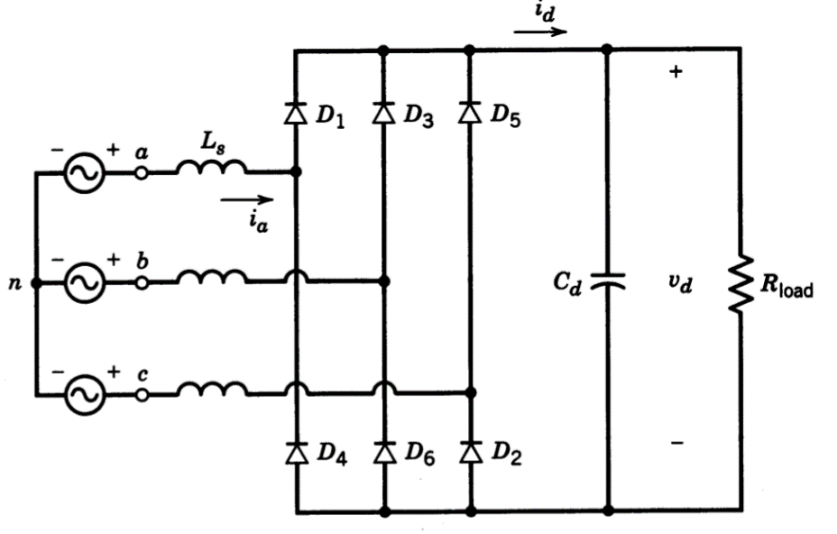

*Figure 1. Three-Phase Diode Rectifier Layout*

The output voltage of this rectifier with respect to input line-to-line voltage can be calculated by:

$V_{av}=\frac{3\sqrt{2}}{π}V_{ll}$

Second part is the buck converter. The layout of a buck converter can be observed in Figure 2. It gets DC voltage as input, rectifies it according to the duty cycle and gives the rectified DC voltage as output. The output voltage can be calculated by:

$V_{out}=V_{in}*D$

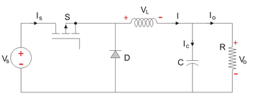

*Figure 2. Buck Converter Layout*

Advantages:

* Three-phase diode rectifier takes grid AC voltage as input and gives DC voltage with decreased rippleas output.
* Even though it consists of a rectifier and converter, this topology is less expensive than the topologies that contain thyristor.
* Only one component needs a gate signal so the layout and synchronization is much simpler than the thyristor-containing topologies.

Disadvantages:

* This topology is not suitable for operating in inverter mode.

### Single Phase Thyristor Rectifier

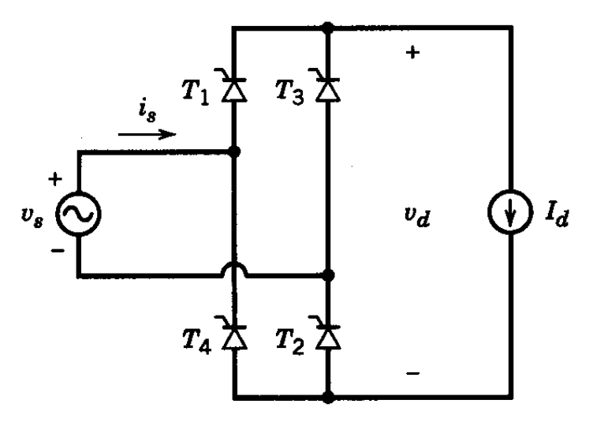

*Figure 3. Single Phase Thyristor Rectifier Layout*

The output voltage of this rectifier with respect to input line-to-line voltage can be calculated (taking α as the firing angle) by:

$V_{av}=\frac{2\sqrt{2}}{π}V_{ph}coscos α$

Advantages:

* It contains four thyristors so it is less expensive compared to the three-phase thyristor version.
* Since it has four thyristors, circuit layout and gate signal synchronization are simpler than in the three-phase thyristor case.
* It can operate in inverter mode.
* The output voltage can be fully controlled via the firing angles.

Disadvantages:

* It costs higher than the three-phase diode rectifier with a buck converter.
* The output voltage ripple is high.
* The average output voltage is lower than the three-phase version.
* In order to drive the thyristor without a problem, driver circuits are needed. This increases the layout complexity and costs extra components.
* It causes harmonic problems in input current.

### Three-Phase Thyristor Rectifier

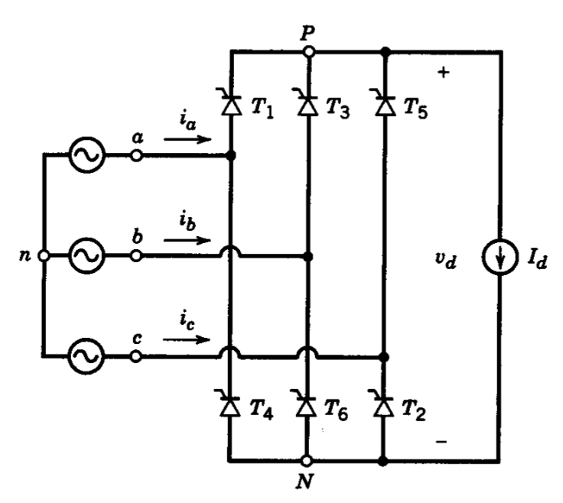

*Figure 4. Three-Phase Thyristor Rectifier Layout*

The output voltage of this rectifier with respect to input line-to-line voltage can be calculated (taking α as the firing angle) by

$V_{av}=\frac{3\sqrt{2}}{π}V_{ph}coscos α$

Advantages:

* This topology results in a lower output ripple voltage compared to the single-phase case.
* The output voltage is fully controlled.
* The average output voltage is higher.
* It is possible to use this topology in the inverter mode.

Disadvantages::

* Since six thyristors are used, it is expensive.
* As the thyristor number increases, gate signal complication increases as well.
* Synchronization and simplification is harder.
* The gate signals of thyristors should be given through drivers. This increases the complexity and cost.

## Topology selection

After analyzing all the advantages and disadvantages of the possible topologies, it is decided to use a three-phase diode rectifier with a buck converter. While deciding, its low cost and simple driving are considered. Moreover, its output voltage range is suitable for the project specifications.

# Rectifier and Converter Calculations

It is decided to use a three-phase diode rectifier to convert AC voltage to DC. The average output voltage of the three-phase diode rectifier can be found as:

$V_{av}=\frac{3\sqrt{2}}{π}V_{ll}$

Then the average output voltage of the rectifier is equal to the input voltage of the buck converter, $V_{av}= V_{in}$. And the output voltage of the buck converter is:

$V_{out}=V_{in}*D$

Where D is the duty cycle. To satisfy the project conditions $V_{out}$ is equal to 180V. And to work safely and efficiently, the maximum value of the duty cycle is 80%. Because are ignored nonidealities such as the commutation effect.

$180V=V_{in}*0.80$

$V_{in}=225 V$

$V_{av}$ $/\frac{3\sqrt{2}}{π}=V_{ll}=225V/\frac{3\sqrt{2}}{π}=166.608 V$

To give 225V to buck converter, 166.608 $V_{ll}$ should be supplied to the rectifier. Considering the rectifier is powered through the variac, the variac’s working percentage should be calculated. Using the explained equations, several calculations are done in order to decide on the values. The results can be observed in Table 1, the analytical choices are done considering that all calculations done under the knowledge of standard RMS voltage in Turkey is 230V, so the variac’s maximum output is $230*\sqrt{3}=398,37$ V.

Table 1: Tabulated results and comparison of voltages and percentages

| | **Buck Converter Output = Motor Input (V)** | **Duty Cycle** | **Rectifier Output   = Buck Converter Input (V)** | **Variac Output(l-l) = Rectifier Input (V)** | **Variac Percentage** | | --- | --- | --- | --- | --- | | 215,196 | 0,8 | 268,995 | 199,186 | 0,5 | | 180 | 0,8 | 225 | 166,608 | 0,418 | | 170 | 0,8 | 212,5 | 157,352 | 0,395 | | 170 | 0,79 | 215,196 | 159,349 | 0,4 | | 170 | 0,63 | 268,995 | 199,186 | 0,5 | | 170 | 0,6 | 283,33 | 209,803 | 0,527 | | 170 | 0,5 | 340 | 251,763 | 0,632 | | 170 | 0,35 | 485,714 | 359,662 | 0,903 | | 134,498 | 0,5 | 268,995 | 199,186 | 0,5 | | 129,118 | 0,6 | 215,196 | 159,349 | 0,4 | | 105 | 0,2 | 525 | 388,752 | 0,976 | | 105 | 0,5 | 210 | 155,501 | 0,390 | | 105 | 0,49 | 215,196 | 159,349 | 0,4 | | 105 | 0,39 | 268,995 | 199,186 | 0,5 | | 43,039 | 0,2 | 215,196 | 159,349 | 0,4 | |
| --- | --- | --- | --- | --- | --- | --- | --- | --- | --- | --- | --- | --- | --- | --- | --- | --- | --- | --- | --- | --- | --- | --- | --- | --- | --- | --- | --- | --- | --- | --- | --- | --- | --- | --- | --- | --- | --- | --- | --- | --- | --- | --- | --- | --- | --- | --- | --- | --- | --- | --- | --- | --- | --- | --- | --- | --- | --- | --- | --- | --- | --- | --- | --- | --- | --- | --- | --- | --- | --- | --- | --- | --- | --- | --- | --- | --- | --- | --- | --- | --- |

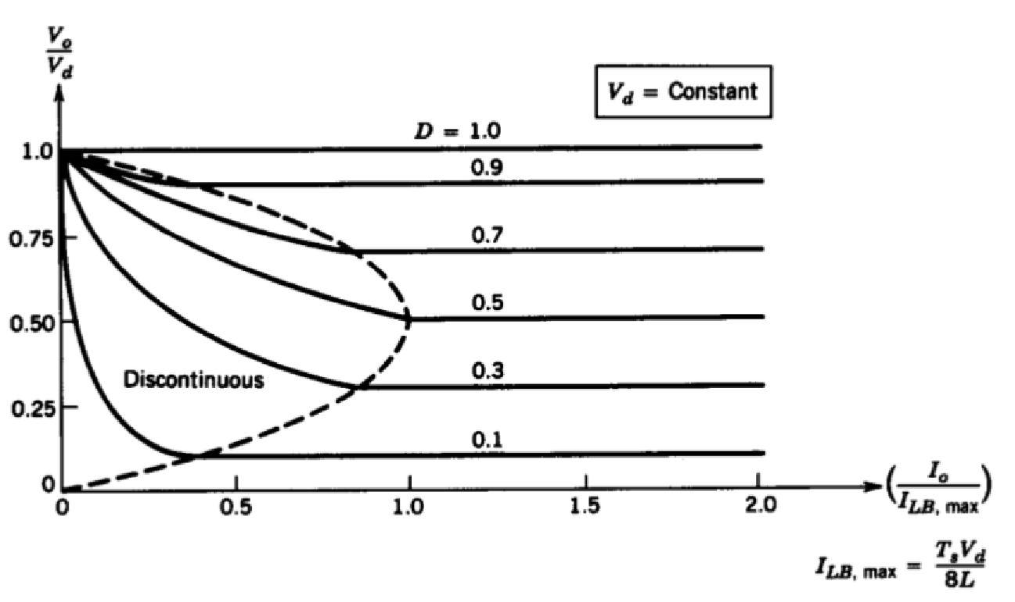

*Figure 5. Output voltage and current relations at Continuous and Discontinuous Conduction Modes*

Assuming $I_{LB}=\frac{i_{L,peak}}{2}=\frac{t_{ON}(V_{d}-V_{o})}{2L}$ with $t_{ON}=DT_{s}$

Then $I_{LB}=\frac{DT_{s}(V_{d}-V_{o})}{2L}=\frac{D^{2}V_{d}}{2Lf_{s}}$ since $f_{s}=D*3280 Hz$ and $\frac{V_{d}}{I_{LB}}=Z_{Load}=0.8Ω$

L $=\frac{D*0.8}{2*3280}=D*0.122$ mH, so $L_{min}=0.122 mH$

As a result, the additional inductor is not needed since the motor has a 12.5 mH inductor.

# Power and Loss Calculations

### At rated condition

VT = 220V, IA=23.4A, BHP=5.5Hp, n=1500rpm

$P_{out} = 5.5 HP =5.5×745,712\frac{W}{HP}=4101.416W$

$τ_{out}=\frac{P_{out }}{{ w}_{rated }}=\frac{4101.416W}{1500×\frac{2π}{60}rad/s}=\frac{4101.461W}{157.08rad/s}=26.13 N/m$

$P_{in}= V_{t}×I_{a}=220V×23.4A=5148W$

$P_{c-loss}=I_{a}^{2}×\left(R_{a}+R_{i}\right)+\frac{V_{T}^{2}}{R_{F}}=816.365W$

$E_{a}=V_{T}-I_{a}×\left(R_{a}+R_{i}\right)=194.962V$

$E_{a}=L_{af}×I_{f}×w_{m }and I_{f}=\frac{V_{T}}{R_{f}}=1.048A$

$L_{af}=1.185H$

$P_{loss}= P_{in}-P_{out}-P_{c-loss}=230.219W$

$τ_{loss }= \frac{P_{loss }}{{ w}_{rated }}=1.466 N/m$; which are losses due to rotation

### At no load condition

At no load condition, all input power is equal to the loss of friction of motor.

VT is chosen 170V.

$E_{a}=V_{T}=170V$

$w_{m }=\frac{E_{a}}{I_{f}×L_{af}}=\frac{170V}{1.048A×1.185H}=136.889 rad/s$

$P_{loss}=τ_{loss }×w_{m }=\frac{1.466N}{m}×\frac{136.889rad}{s}= 200.68W$

### At kettle load condition

There is 200.68W loss due to friction. This loss is seen both in the motor and generator. So, the total rotation loss will be 401.36W. As a result, the electromechanical power output will be 2401.36W to boil water in a kettle. In addition, VT is chosen as 170V.

$P_{mech}=E_{a}×I_{a}$

$E_{a}=V_{T}-I_{a}×(R_{a}+R_{i})$

$P_{mech}=2401.36W =(V_{T}-I_{a}×\left(R_{a}+R_{i}\right))×I_{a}$

$I_{a}=15.671A and E_{a}=153.232V$

$w_{m }=\frac{E_{a}}{I_{f}×L_{af}}=\frac{153.232V}{1.048A×1.185H}=123.387 rad/s$

### At start-up

Wm=0 rad/s and Ea=0

VT is chosen 170V.

$I_{a}=\frac{V_{T}}{\left(R_{a}+R_{i}\right)}=158.878A$

This current rating is too much, and it can damage the motor. As a result, the motor cannot be started with the chosen voltage rating.

# Simulation of the Selected Topology

## 6.1. Simulation Results Prepared Before Feedback Session

In the simulation, the AC voltage source was selected as 136V line to line. The motor parameters were arranged according to power and loss calculation. The soft starter was used to limit the motor input current. In Figure 10, the layout that is used to simulate the system can be observed.

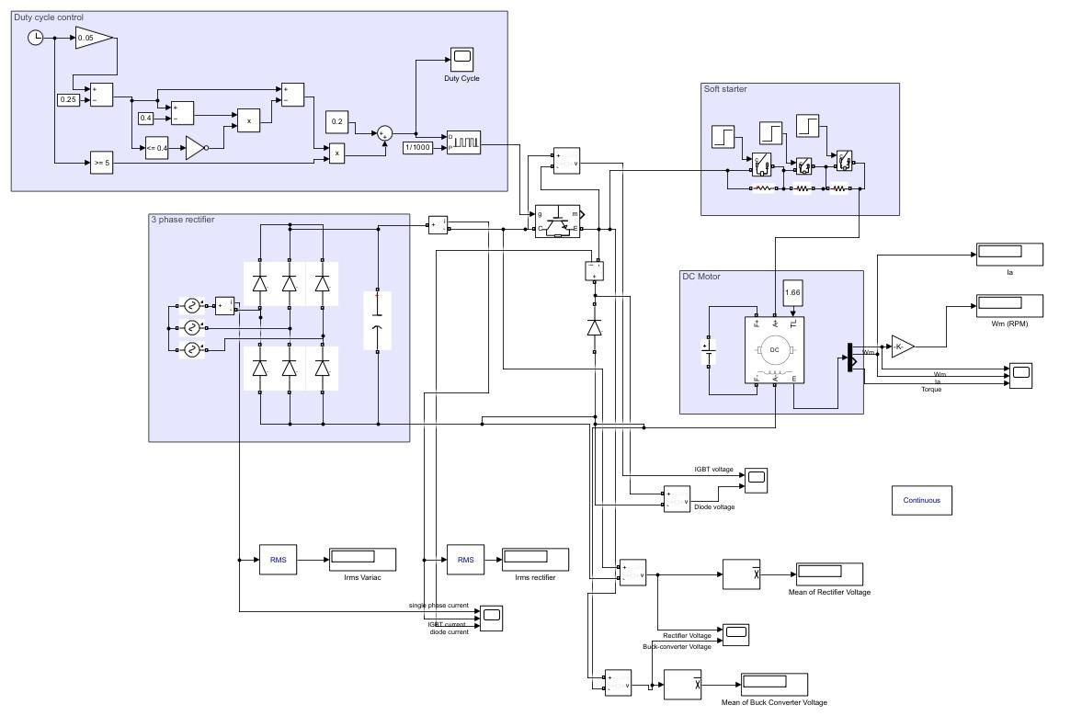

*Figure 6. Simulation Layout of the Selected Topology*

In Figure 11, it can be seen that the input current rises suddenly when there is no soft starter. This high current can damage the motor and components. As a result, the current must be limited at starting.

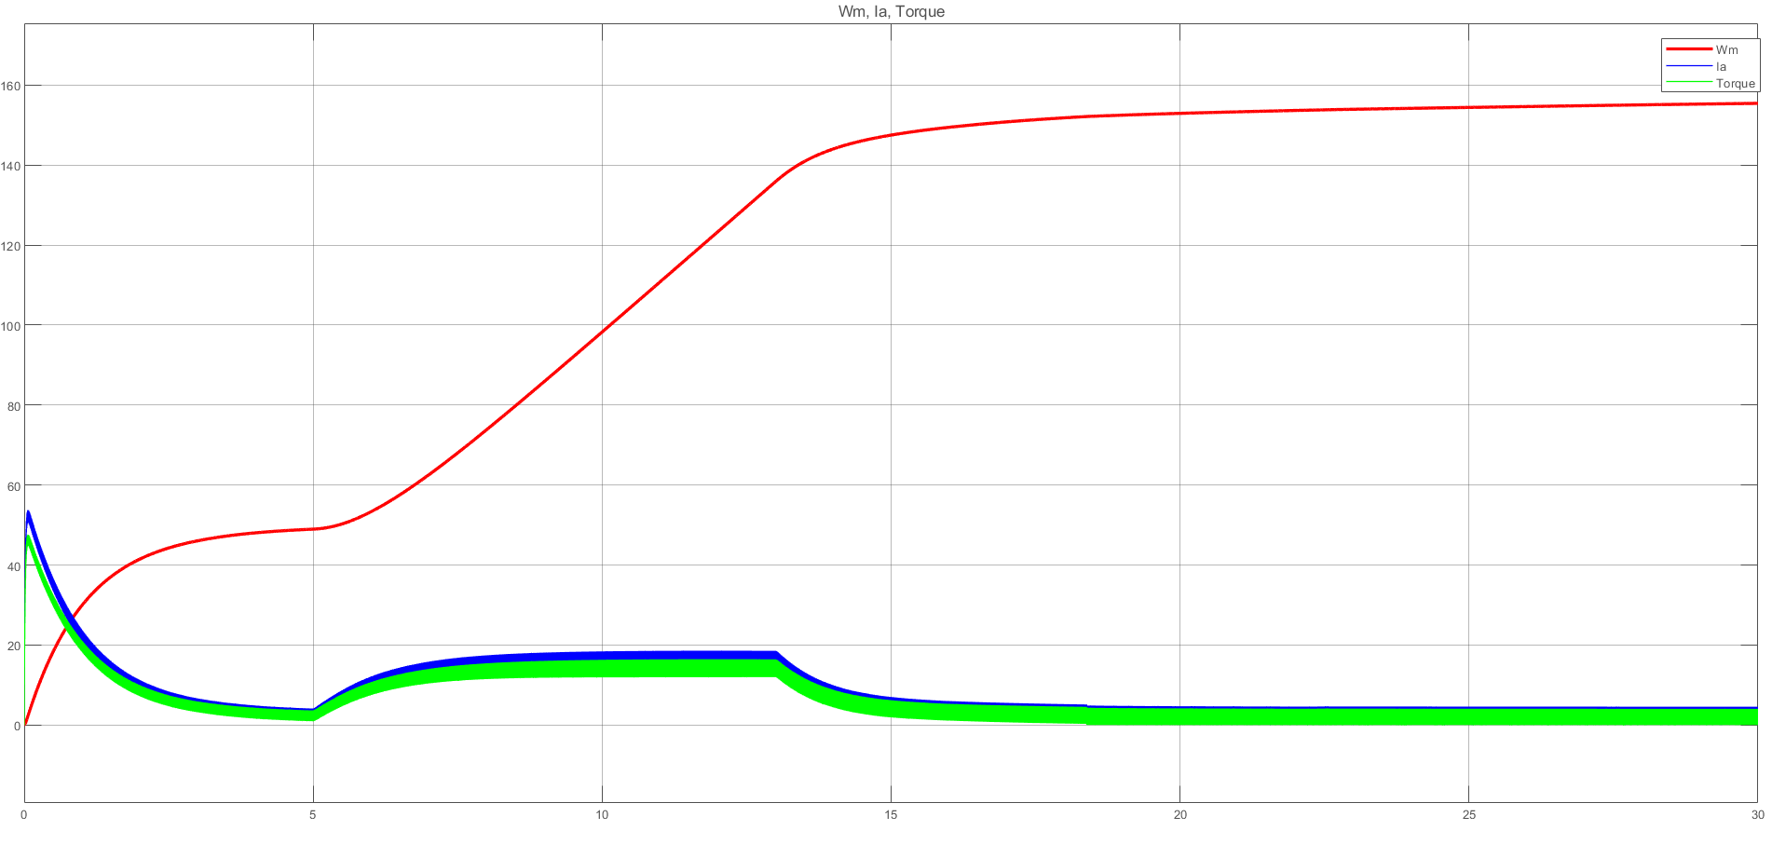

*Figure 7. Wm, Ia, and Torque of the motor without a soft starter, timespan 0 to 30 seconds*

In the soft starter system applied in the simulation, extra resistances are connected to the system, so the current reach lower values. As Ea increases, current decreases. So the resistance is gradually reduced to increase the current. Thus, the motor is enabled to operate before the current rises to dangerous levels.

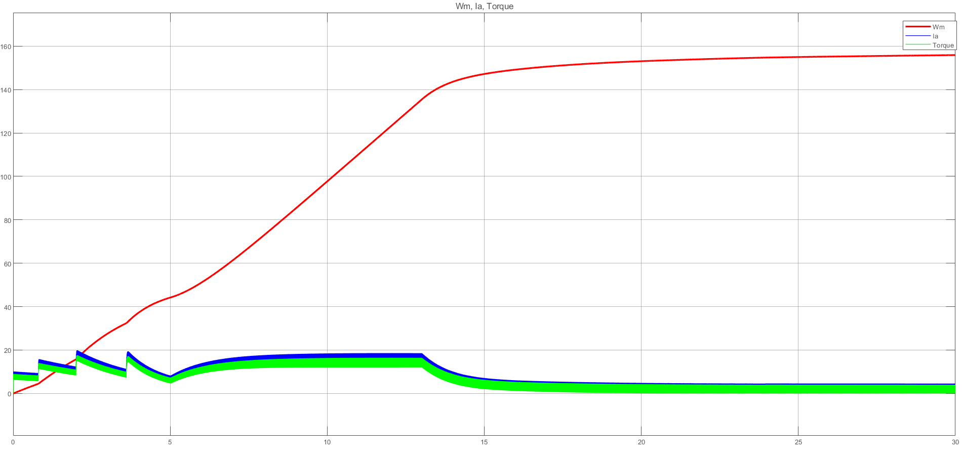

*Figure 8. Wm, Ia, and Torque of the motor with soft starter, timespan 0 to 30 seconds*

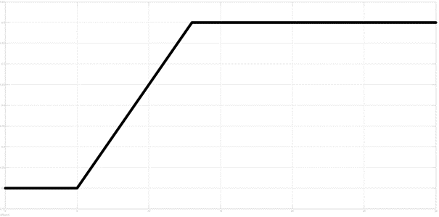

*Figure 9. Duty Cycle Change at No Load Case*

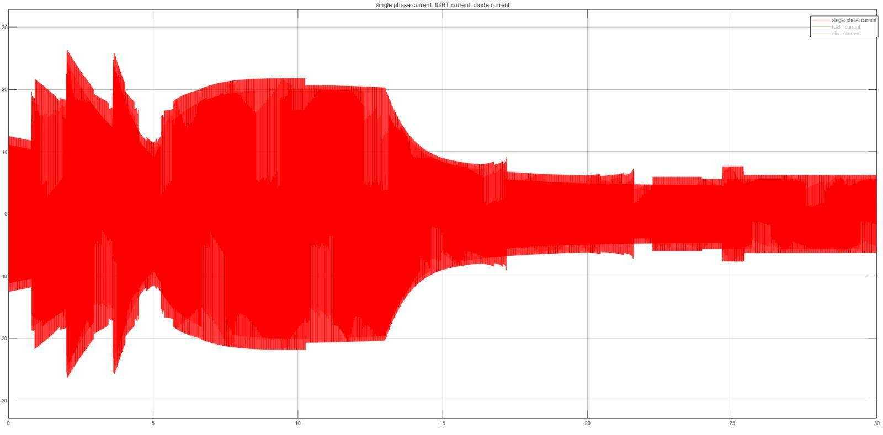

*Figure 10. Phase Current at No Load Case*

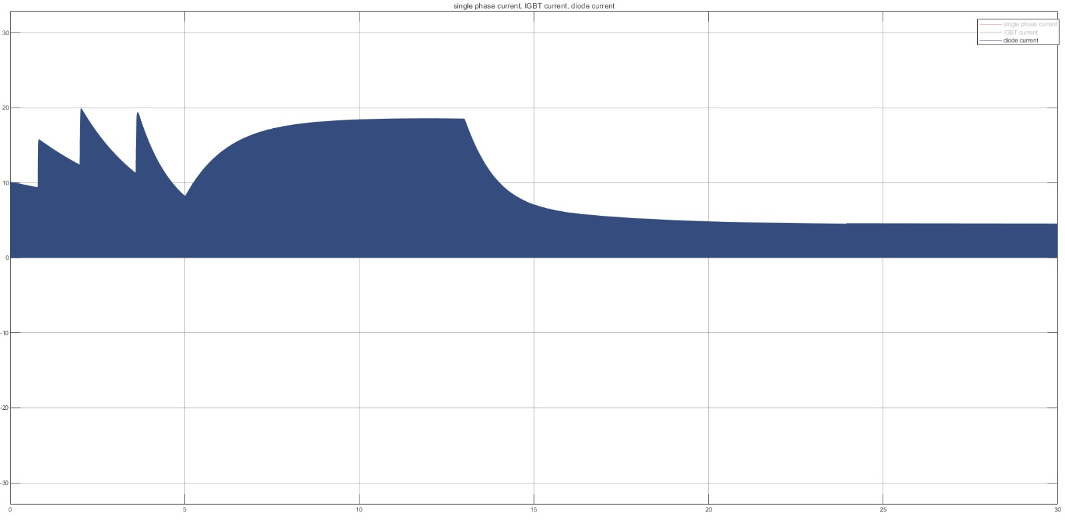

*Figure 11. Diode Current at No Load Case*

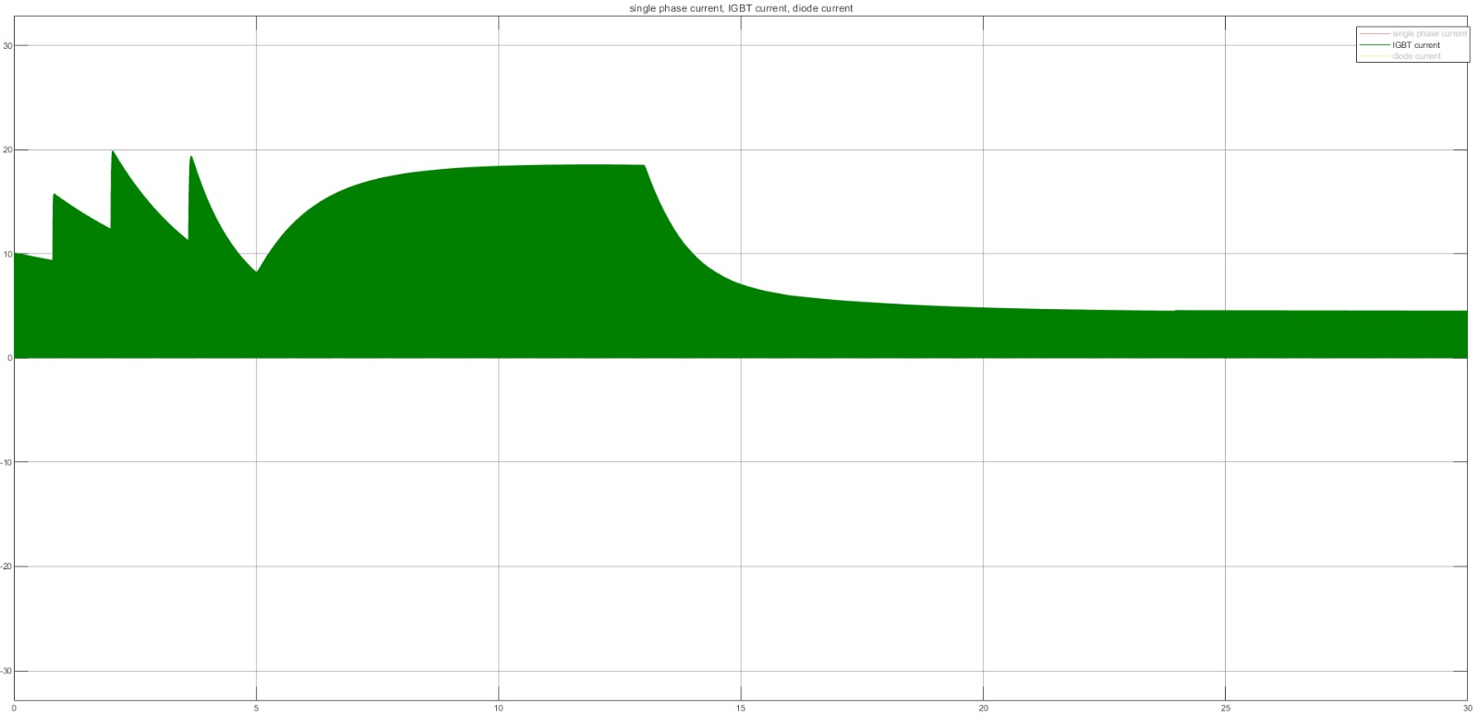

*Figure 12. IGBT Current at No Load Case*

The average voltage at the DC motor can be adjusted by changing the duty cycle value. In Figure 17, adjusting D to 0.2 makes the mean voltage of the DC machine equal to %20 of the output voltage of the rectifier circuit. On the other hand, in Figure 18, the DC machine input average equals 80% of the output voltage of the rectifier circuit by adjusting D to 0.8.

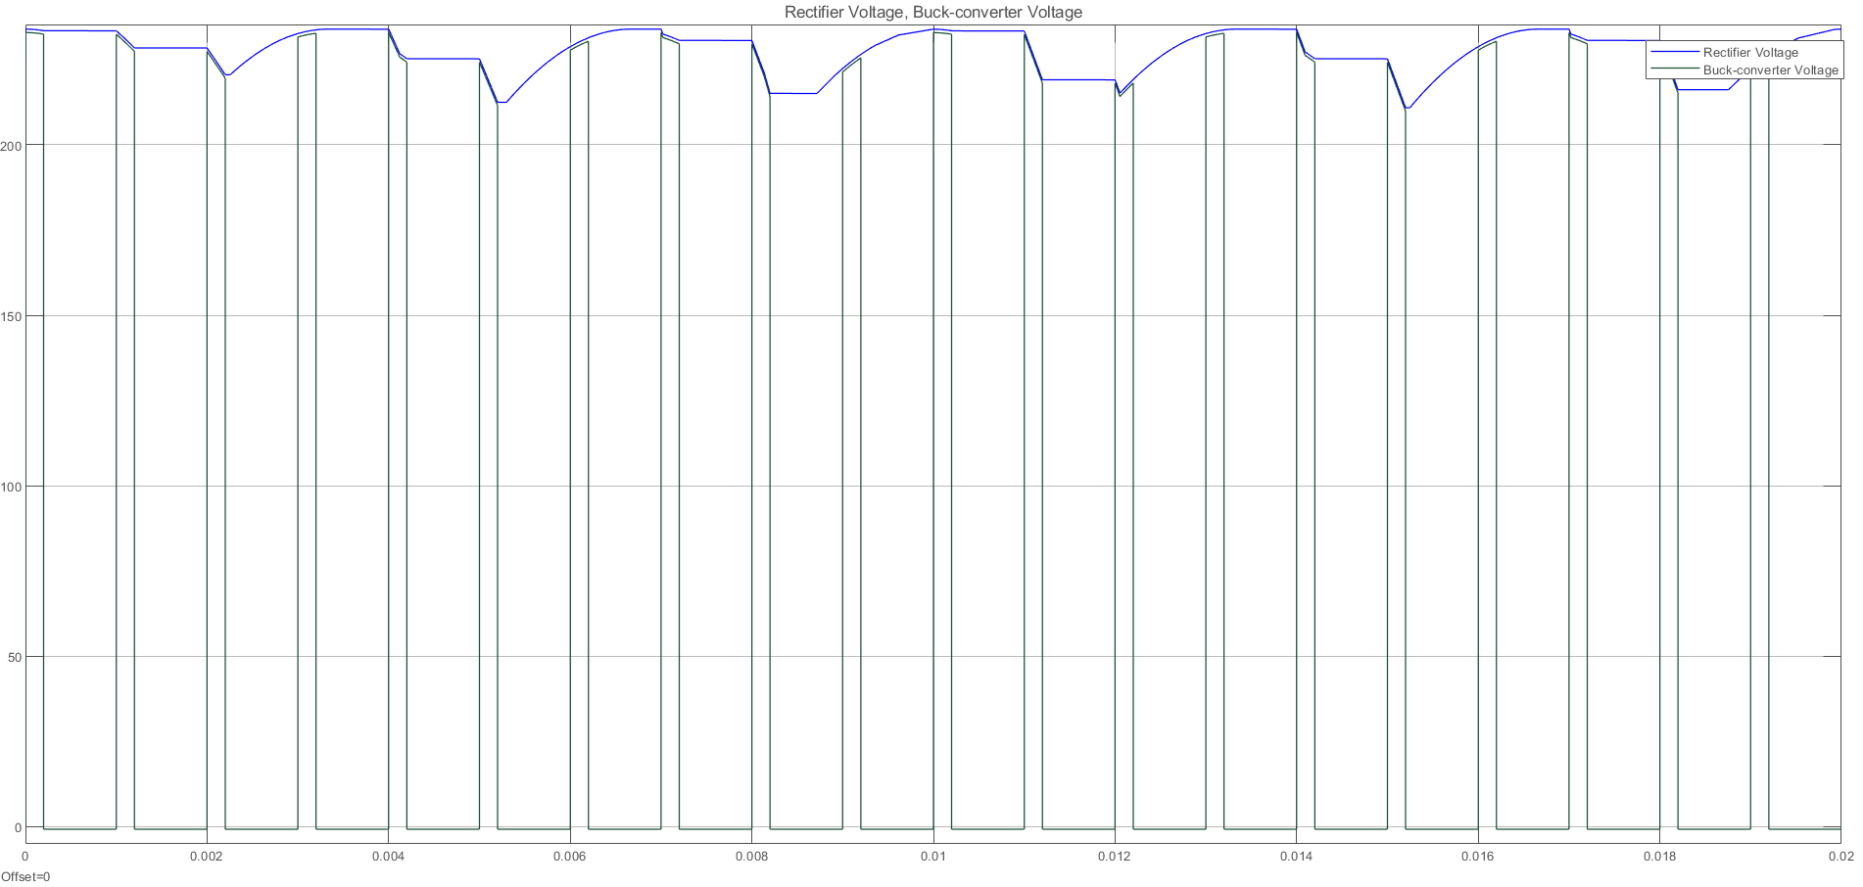

*Figure 13. Three-Phase Rectifier and Buck Converter Output Voltage at D=0.2*

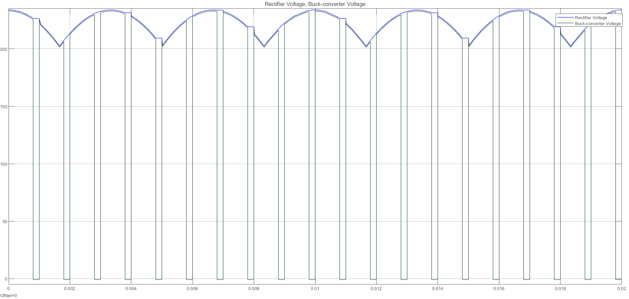

*Figure 14. Three-Phase Rectifier and Buck Converter Output Voltage at D=0.8*

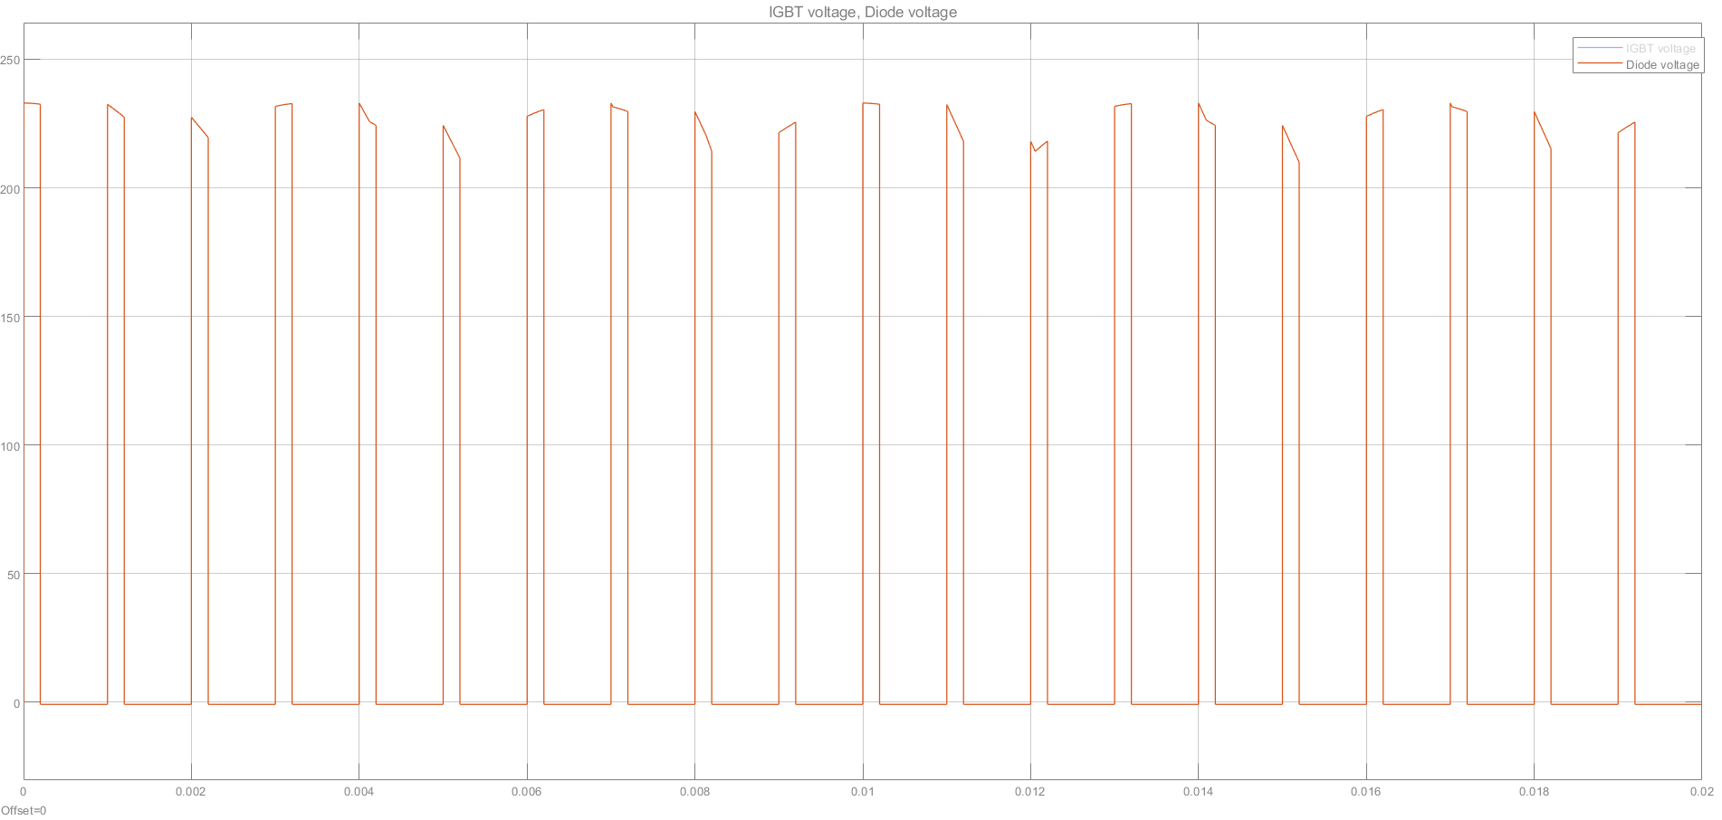

*Figure 15. Diode Voltage at D=0.2*

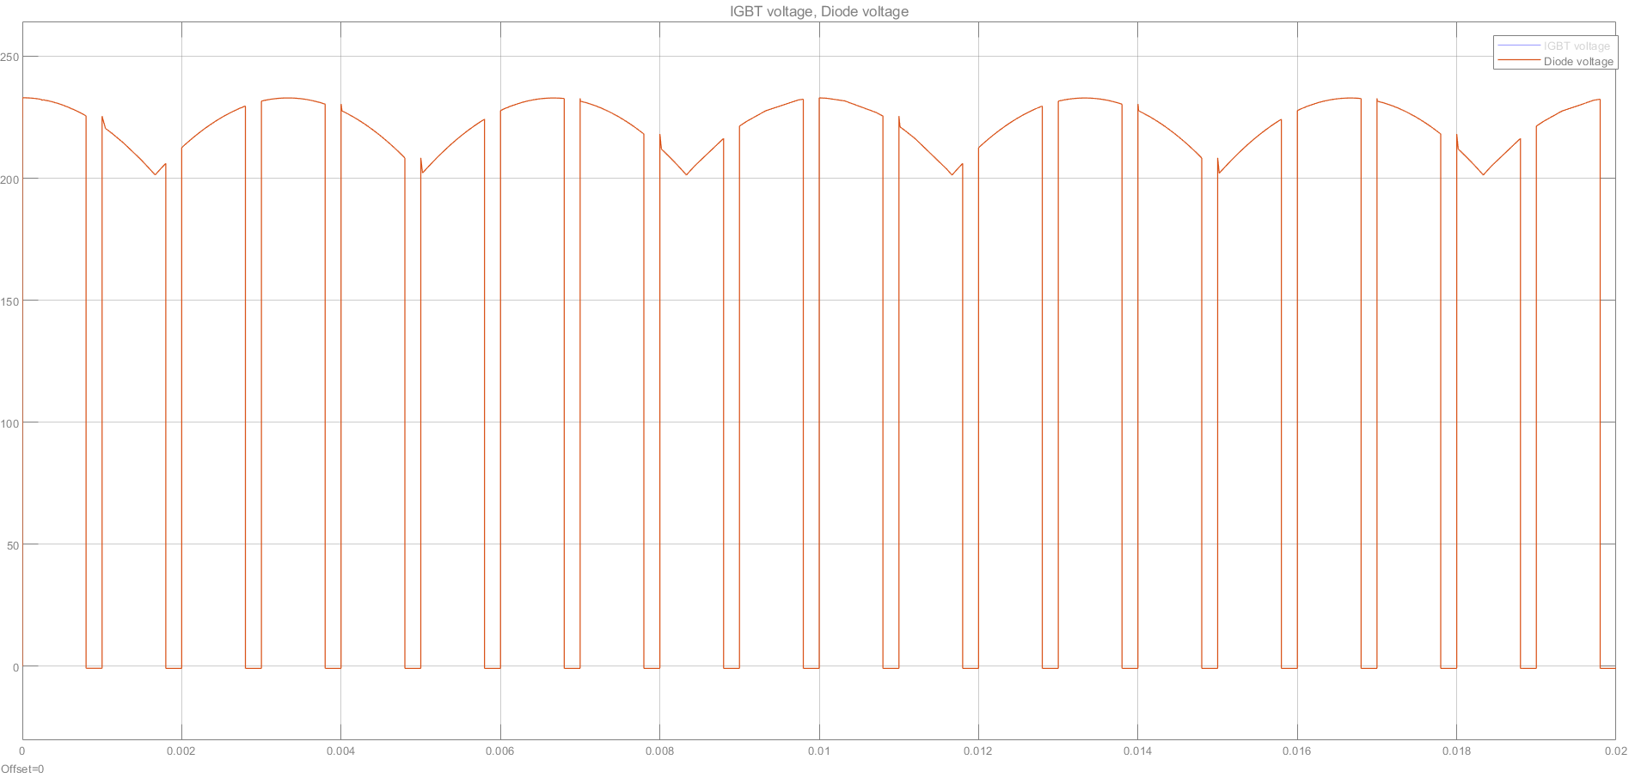

*Figure 16. Diode Voltage at D=0.8*

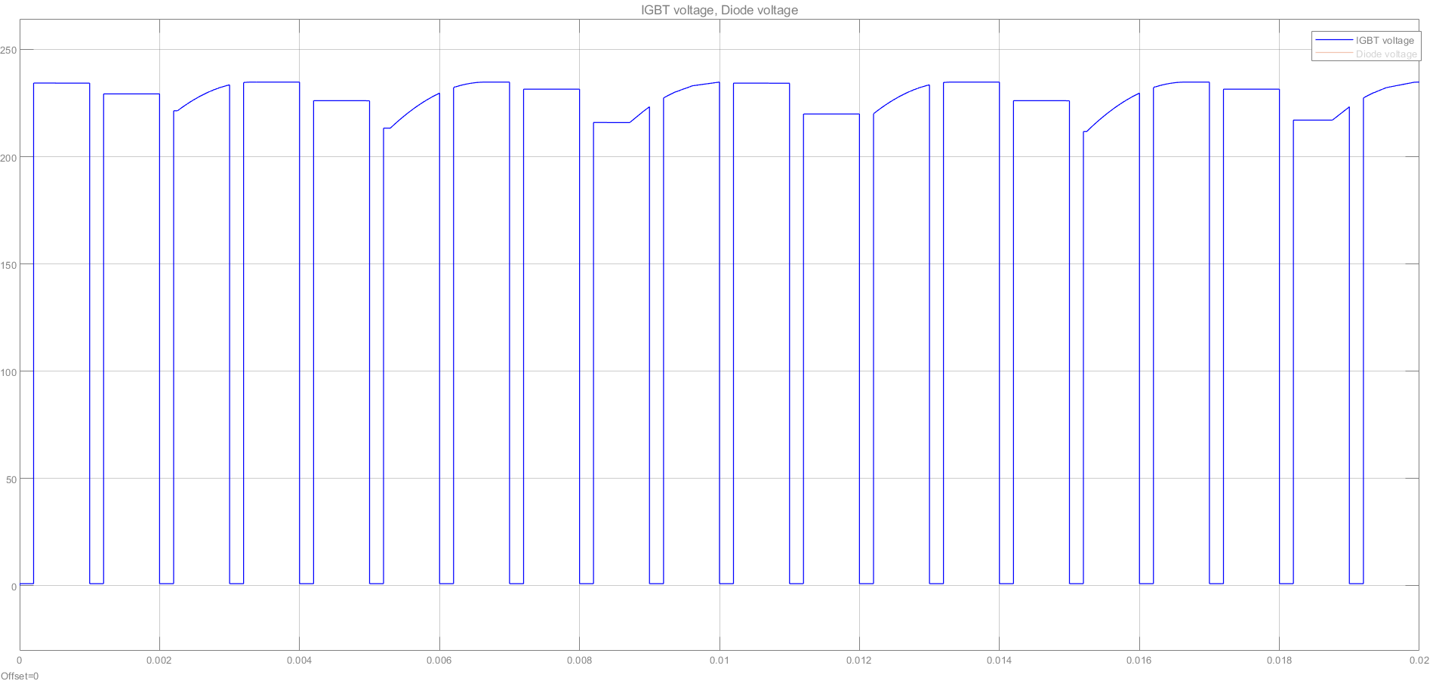

*Figure 17. IGBT Voltage at D=0.2*

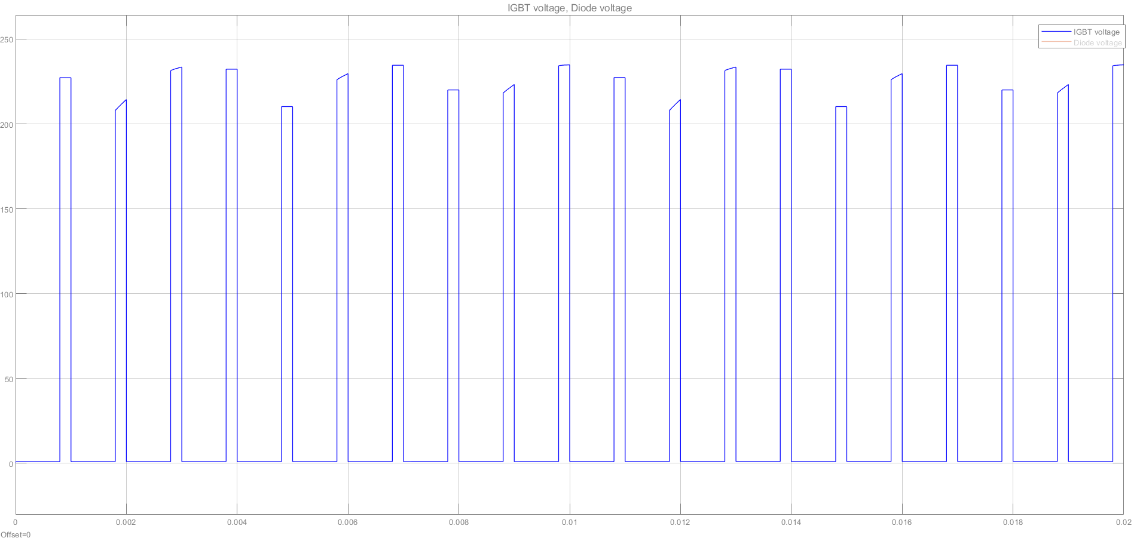

*Figure 18. IGBT Voltage at D=0.8*

## 6.2. Simulation Results Prepared After the Feedback Session

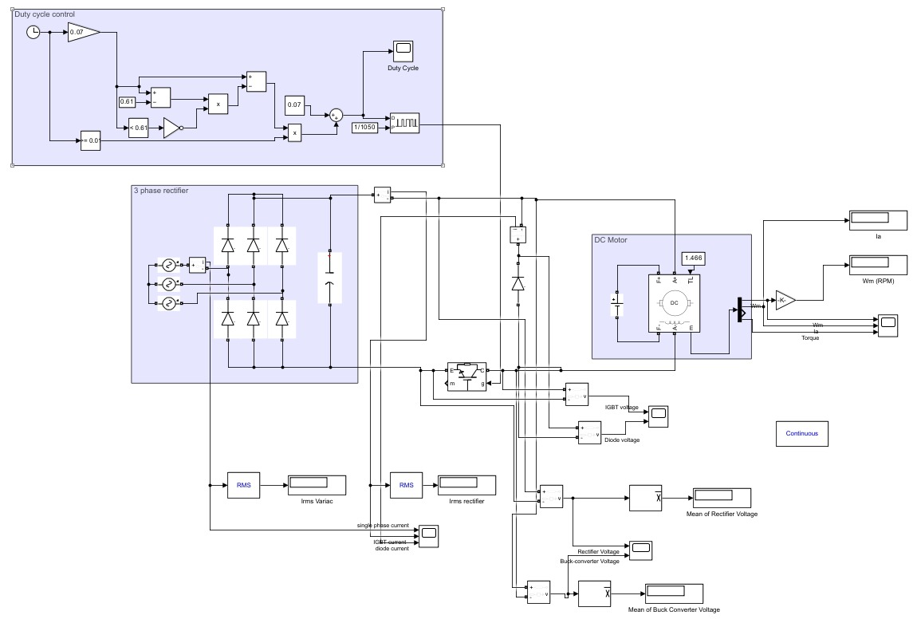

*Figure 19. Simulation Layout of the Selected Topology*

### 6.2.1. At no load

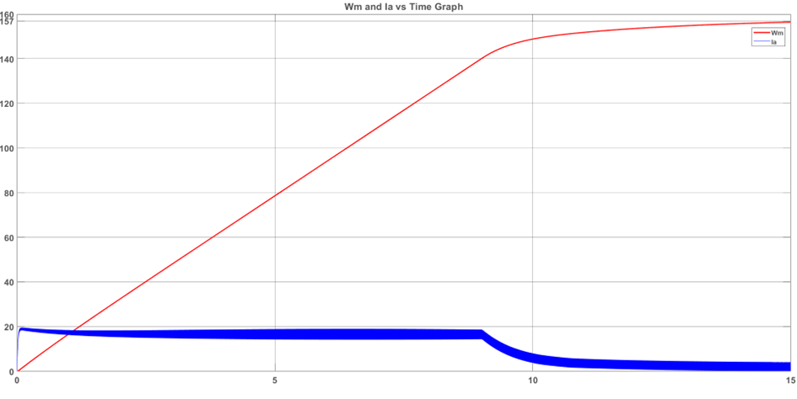

*Figure 20: Wm and Ia of the motor with soft starter, timespan 0 to 15 seconds at no load condition*

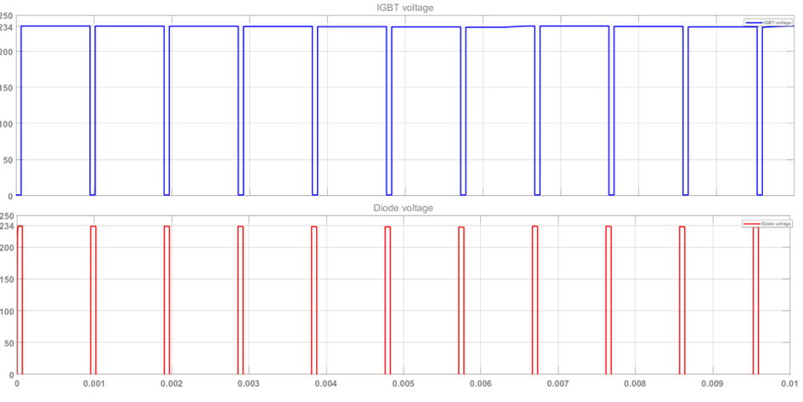

*Figure 21: IGBT and Diode Voltage at the beginning*

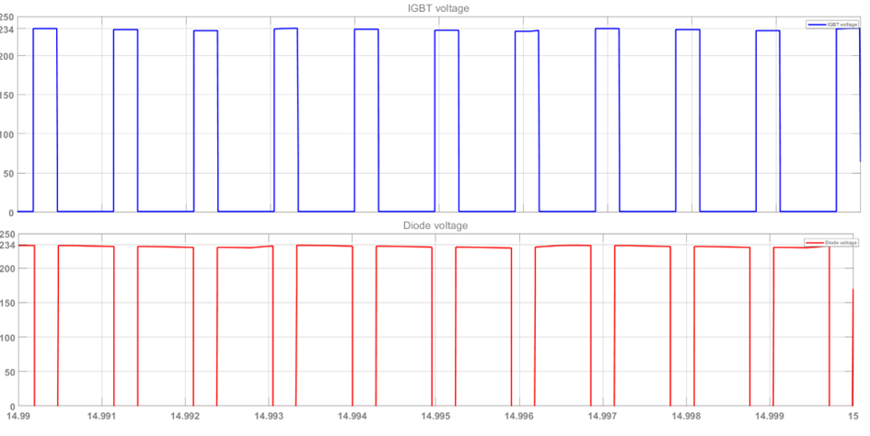

*Figure 22: IGBT and Diode Voltage at steady state*

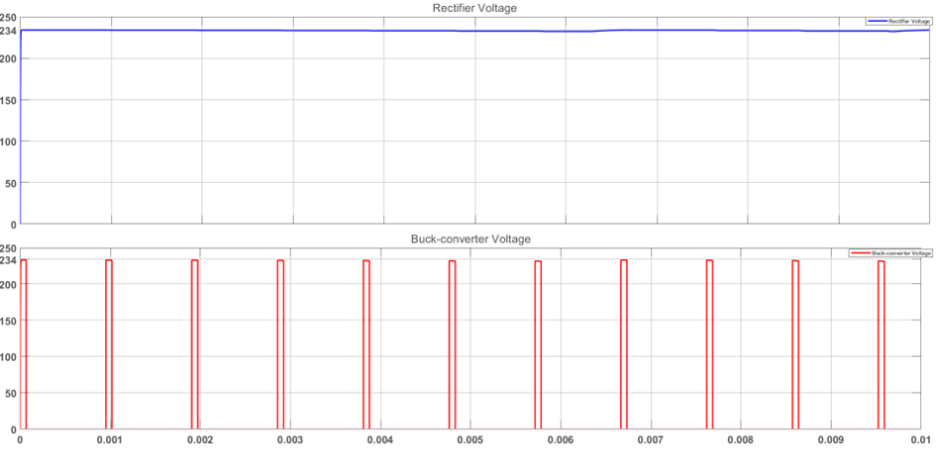

*Figure 23: Rectifier and Buck Converter Voltage at the beginning*

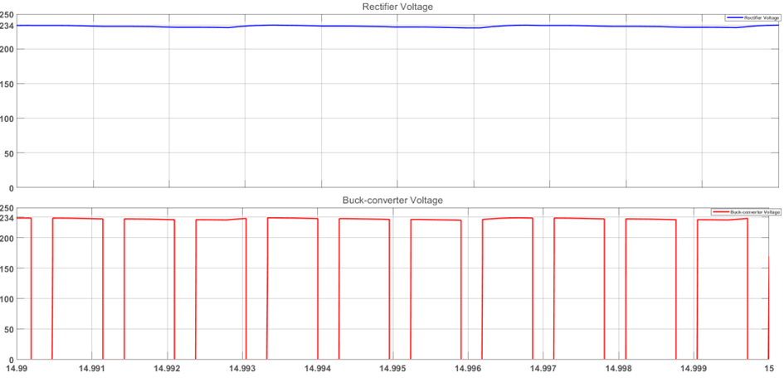

*Figure 24: Rectifier and Buck Converter Voltage at steady state*

### 6.2.2. When the Load is 1.4kW

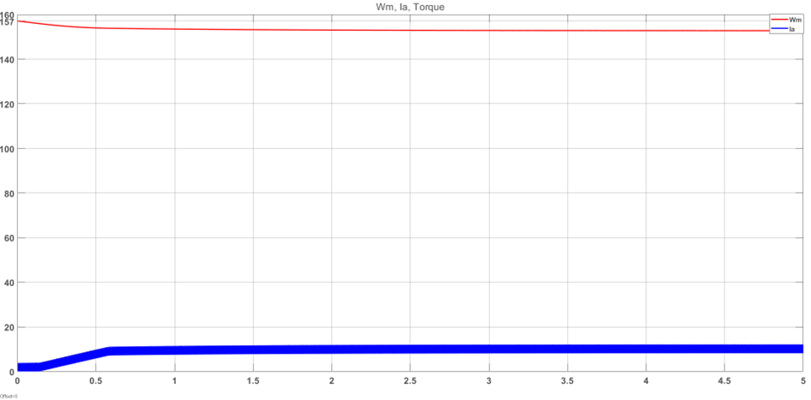

Figure 25: *Wm and Ia of the motor with soft starter, timespan 0 to 15 seconds*

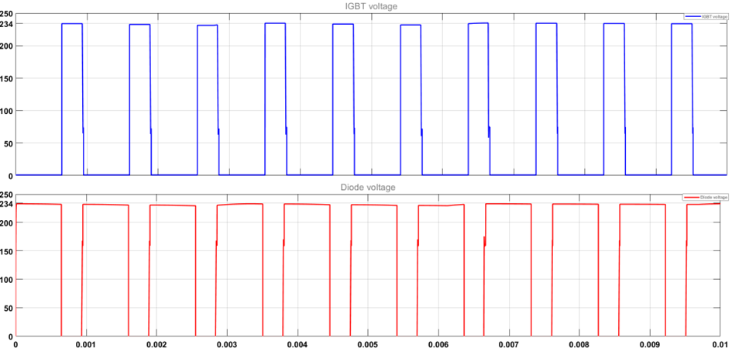

*Figure 26: IGBT and Diode Voltage at the beginning*

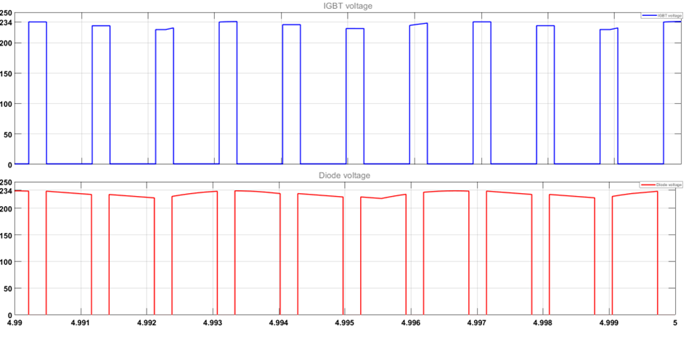

*Figure 27: IGBT and Diode Voltage at steady state*

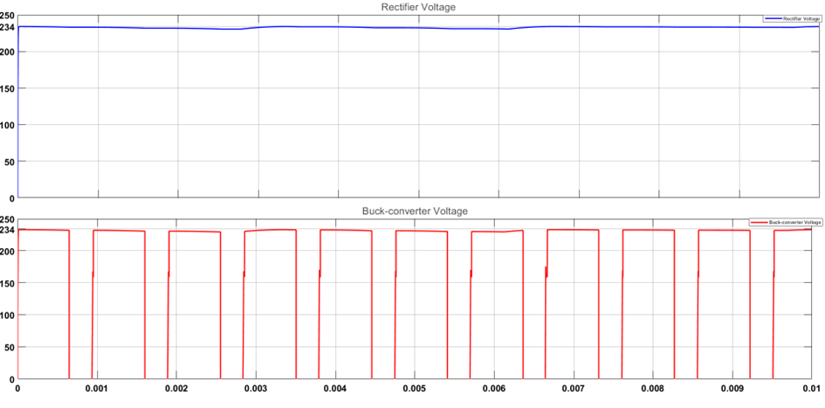

*Figure 28: Rectifier and Buck Converter Voltage at the beginning*

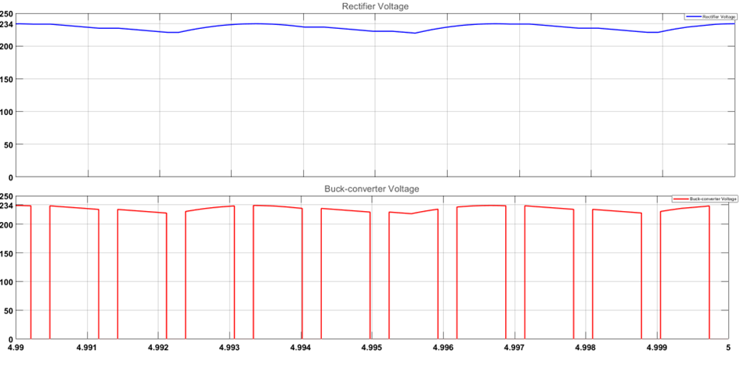

*Figure 29: Rectifier and Buck Converter Voltage at steady state*

### 6.2.3. When Load is 2kW

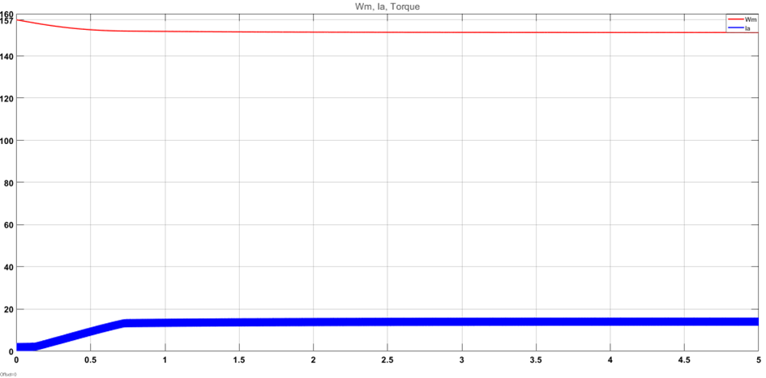

Figure 30: *Wm and Ia of the motor with soft starter, timespan 0 to 15 seconds*

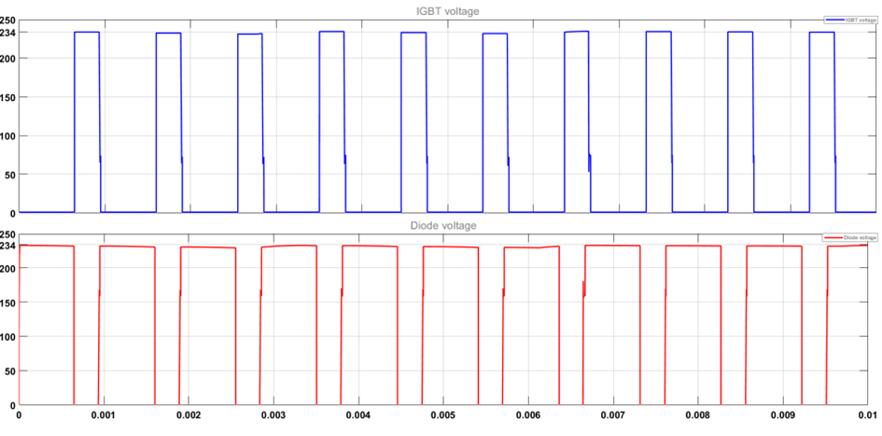

*Figure 31: IGBT and Diode Voltage at the beginning*

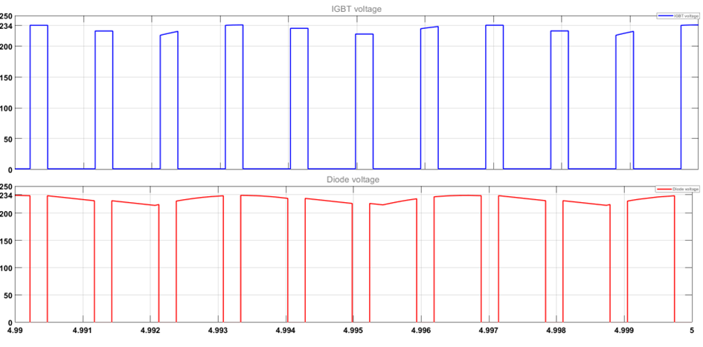

*Figure 32: IGBT and Diode Voltage at steady state*

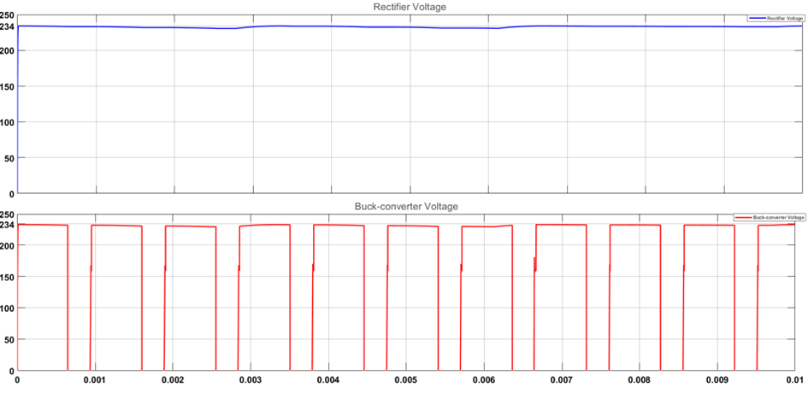

*Figure 33: Rectifier and Buck Converter Voltage at the beginning*

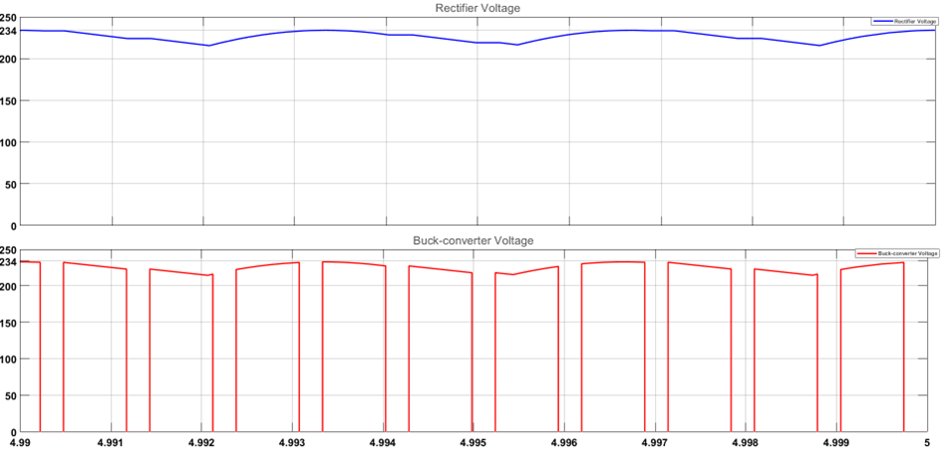

*Figure 34: Rectifier and Buck Converter Voltage at steady state*

# Control Mechanism and Its Implementation Problem

In this project, a control mechanism was designed. However, due to the current sensor error, it could not be implemented. The aim of this control mechanism is to speed up the motor until its speed reaches the level that is desired. It includes a soft starting mechanism since the current which is higher than 23.4 A can cause damage to the motor.

In our design, the output voltage (terminal voltage of the motor) should not exceed 180V. Moreover, since our instructor does not allow us to have a 100% duty cycle, we give 136sin(100πt) from variac, which results approximately 234V at the output of the rectifier circuit. In order to limit the maximum voltage at the terminal voltage:

$D_{max} (\%)=\frac{180}{234}*100=76.92\%$

Also, while starting the motor, we need to limit the duty cycle in order not to exceed 23.4 A, which is the rated current.

$D_{start}(\%)≤\frac{23.4*0.8}{234}*100=8\%$

At steady state

$T = I_{f}*L_{af}*I_{a}$

$T = \frac{P_{m}}{w_{m}}$

$E_{a}= V_{t}-R_{a}*I_{a}$

$V_{t}= D*V_{rectifier}$

Since $V_{rectifier}$ =234V→ $V_{t}$ =234*D

As it is specified in Power and Loss Calculation part

$P_{Loss}$ = 230.22 W

$L_{af}$ =1.185 H

$w_{m}$ = 157.08 rad/s at 1500 rpm rated speed.

Also, during the demo $V_{f}$ = 180 V is given.

Hence, at No Load:

$I_{f}=\frac{V_{f}}{R_{f}}=\frac{180}{210}=0.857A$

$I_{a}=\frac{P_{Loss}}{I_{f}*L_{af}*w_{m}}=1.443A$

$E_{a}=\frac{P_{Loss}}{I_{a}}=\frac{230.22}{1.443}=159.543V$

$V_{t}=E_{a}+R_{a}*I_{a}=160.69V$

$D = \frac{V_{t}}{V_{rectifier}}=68.67\%$

Hence final D is 69% for no load condition. Starting from 8% to 69%, we need a control mechanism so that the current does not exceed 23.4A. In the Arduino code, we write a function that controls the current by gradually increasing the duty cycle until the desired speed or voltage while desired voltage is determined by the POT.

* Using POT, we limit the Duty cycle, which is between 0 and 77%.
* Since we know the rectifier voltage, by taking the current value from the sensor, we can determine the Back-EMF voltage, which is limited($E_{a,max}$ =159.55V), since the motor speed rating is 1500 rpm.
* The maximum current is limited to 22 A even though the maximum current is 23.4 A for safety.
* While starting D = 8% to the D, which corresponds to the desired voltage level, by controlling the duty cycle, the current level is 22 A until the motor reaches the desired voltage level or when the speed reaches 1500 rpm.
* If the motor reaches 1500 rpm speed, then the Duty cycle is immediately set to 69%.
* After a period, by checking the current level Duty cycle increases gradually until E_a reaches 159.5 V, which is calculated from $D*V_{rectifier}=E_{a}+R_{a}*I_{a}$.
* The design can work until $P_{max}=(180-0.8*23.4)*23.4=3774 W$.

# Controller and Gate Driver

To control the buck converters duty cycle, the gate signal of the IGBT is controlled. To do so, a controller and a gate driver are used. The controller was originally planned to contain a current sensor and an Arduino, but due to an implementation problem: a potentiometer was used with an Arduino. Then the gate driver is chosen as the optocoupler, TLP250.

## Potentiometer and Arduino

After deciding that the current sensor was not the best choice for the project, the team changed the plans and decided to use a potentiometer while generating the duty cycle. To do so, the voltage signal from the potentiometer is taken via the “analogRead” function of the Arduino, and the Arduino generated the PWM accordingly. The Arduino code that is used can be observed in figure 35.

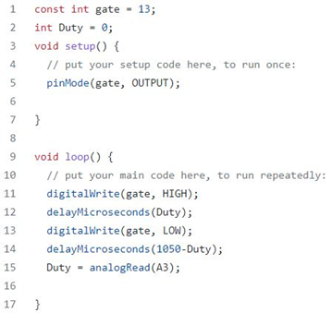

*Figure 35: the Arduino code used to generate PWM*

Since the data taken via the analogRead function has the range 0-1023 and the team wanted to give a safety margin, the period is decided to be 1050 microseconds.

## Optocoupler

The voltage of the PWM generated by the Arduino is not suitable for the IGBT, so a gate driver is needed. As the gate driver, an optocoupler (TLP250) is chosen.

The PWM signal generated is given to the optocoupler from its anode pin, and the cathode pin is connected to Arduino's ground pin. From the VCC pin of the optocoupler, the wanted magnitude is given. Then from its Vo pin, the optocoupler is connected to the IGBT gate through a resistor. The resistor is chosen to be 47Ω. And finally, the GND pin of the optocoupler is connected to the emitter of the IGBT.

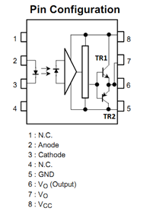

*Figure 36: TLP250 Pin Configuration*

# Component Selection

## Planned Component List

### **Bridge Rectifier**

It was decided to use a 3 phase full-bridge rectifier module due to its size being smaller than the rectifier built with six diodes. In addition, this is a more economical solution.

From simulations, the variac voltage was decided to be 136V. However, choosing a rectifier that can stand grid voltage is more appropriate. In simulations, the peak current was found to be 25.7 A. As a result, it was decided to choose a rectifier that could stand 30 A and 300V reverse voltage.

Table 2: Features of selected bridge rectifiers

| Product name | Bridge Output Current | Max repetitive reverse blocking voltage | Forward Voltage Drop |
| --- | --- | --- | --- |
| GUO40-12NO1 | 40A | 1200V | 1.28V |
| GUO40-16NO1 | 40A | 1600V | 1.28V |
| FUO50-16N | 50A | 1600V | 1.50V |

### **IGBT**

In the simulation, IGBT that has a 30A collector current and 600V collector-emitter voltage was used. Then it was observed that the peak collector current of IGBT is 26.11A. The team decided that the IGBT must have a minimum 30A collector current capability, and the IGBT in the laboratory has this property.

Table 3: Features of selected IGBTs

| Name | Collector current | Collector-Emitter Voltage | Gate Charges |
| --- | --- | --- | --- |
| IXGH24N60C4D1 | 45A at 25C  39A at 100C | 600V | 167nC |
| FGW40N65WE | 56A at 25C  40A at 100C | 650V | 180nC |

### **Diode**

In the simulation, it was found that the peak current is 20A when 140V is applied. However, this voltage can increase up to 180V. As a result, the team decided to choose a diode with 25A current rate and 200V reverse blocking voltage.

Table 4: Features of selected diodes

| Name | Forward Current | Reverse Blocking Voltage | Reverse recovery time | Forward Voltage Drop |
| --- | --- | --- | --- | --- |
| DSEI30-06A | 37A | 600V | 35ns (max 50ns) | 1.6V |
| DHG 30I600PA | 30A | 600V | 40ns (max 60ns) | 2.27V |
| MBR40200PT_T0_10001 | 40A | 200V | - | 0.9V |

### **Capacitor**

In the simulation, a 100µF capacitor was used, and this gives a 22V ripple. In addition, it operated under 183.67V. However, it was calculated that if 170V is supplied to the motor with a 0.6-duty cycle, the capacitor operates on 283V. So a capacitor with 100uF and 400V was chosen.

## **Used Components**

Table 5: Used Components List

| Component | Cost |
| --- | --- |
| Bridge Rectifier - GUO40-12NO1 | 250,42 TL |
| IGBT - IXGH24N60C4D1 | 95,99 TL |
| Diode - DSEI30-06A | 56,79 TL |
| Capacitor x 2 | 155.18 TL |
| Arduino Nano | 159,88 TL |
| Optocoupler - TLP 250 | 47,92 TL |
| Current Sensor - ACS 712 | 47,30 TL |
| DC-DC Step Down - LM2596 | 26,20 TL |
| Potentiometer | 4,66 TL |
| Stone Resistor(47Ω) | 6,21 TL |
| Heatsink- 45AS | 17,75 TL |
| Heatsink x2 | 100 TL |
| Stripboard | 40 TL |

Total cost = 868,30 TL

# Thermal Calculations

Since the components will heat up when the load is connected, this may cause damage to the components. For this reason, thermal calculations have to be made, and according to the calculation, heatsink selection will be made.

This calculation was made according to the simulation. The frequency was chosen at 1kHz, and the duty cycle was 0.77.

### Bridge Rectifier

$R_{th,ch}=0.5K/W$;(Thermal Resistance case to heatsink)

$V_{forward}=1.28V$;(${when I}_{F}=30A$)

$P_{loss}=6 × 1.28V × 7.55A×0,77 = 44,65 W$

$T_{junction}=T_{ambient} +P_{loss}×R_{eq}$, if we want $T_{junction}$ =100C then

$\frac{T_{junction}-T_{ambient} }{P_{loss}}=R_{eq} =R_{th,ch}+R_{heatsink}$

$R_{heatsink} =1.18 C/W$

### IGBT

$R_{th,ch}=0.8K/W$;(Thermal Resistance case to heatsink)

$P_{conduction}=V_{on}×I_{on}×D=1.5V×19.60A ×0,77 = 22.64W$

$P_{switching}=f_{sw}×(E_{on}+ E_{off})=1kHz×1.46mJ=1.46W$

$T_{junction}=T_{ambient} +P_{loss}×R_{eq}$, if $T_{junction}$ =100C selected then

$\frac{T_{junction}-T_{ambient} }{P_{loss}}=R_{eq} =R_{th,ch}+R_{heatsink}$

$R_{heatsink} =2.31 C/W$

### Diode

$R_{th,ch}=1K/W$;(Thermal Resistance case to heatsink)

$P_{conduction}=V_{forward}×I_{F}×D=1.6V×19.60A ×0,77= 24,15W$;(${when I}_{F}=30A$)

$P_{switching}=V_{reverse}×I_{rr}×t_{rr}×f_{sw}×0.5 = 220V×10A×50ns×1kHz×0.5=55W$

$T_{junction}=T_{ambient} +P_{loss}×R_{eq}$, if we want $T_{junction}$ =125C then

$\frac{T_{junction}-T_{ambient} }{P_{loss}}=R_{eq} =R_{th,ch}+R_{heatsink}$

$R_{heatsink} =0.2634 C/W$

### Conclusion

It was decided that the heatsink would be connected to the bridge rectifier, IGBT, and diode. The heatsinks were selected experimentally.

First, all of them are connected 45AS heatsink. However, IGBT and bridge rectifier heated up much. To prevent heating problems, they were changed to larger ones.

# Implementation Process

Throughout the project, the design is tried to be as industrially convenient as possible. to do so, the team considered using a PCB board but decided not to use it due to the limited time and knowledge of PCB designing. Instead, a neat design is implemented on a stripboard where all component placements are measured and planned. First of all, the sizes of the components are considered. Then which components would be heated and which ones would be with a heatsink are noted. After that, component locations on the stripboard are finalized in the most logical and optimal way possible. Finally, soldering and cabling processes are done carefully.

The finalized stripboard board can be observed in figures 37, 38, and 39.

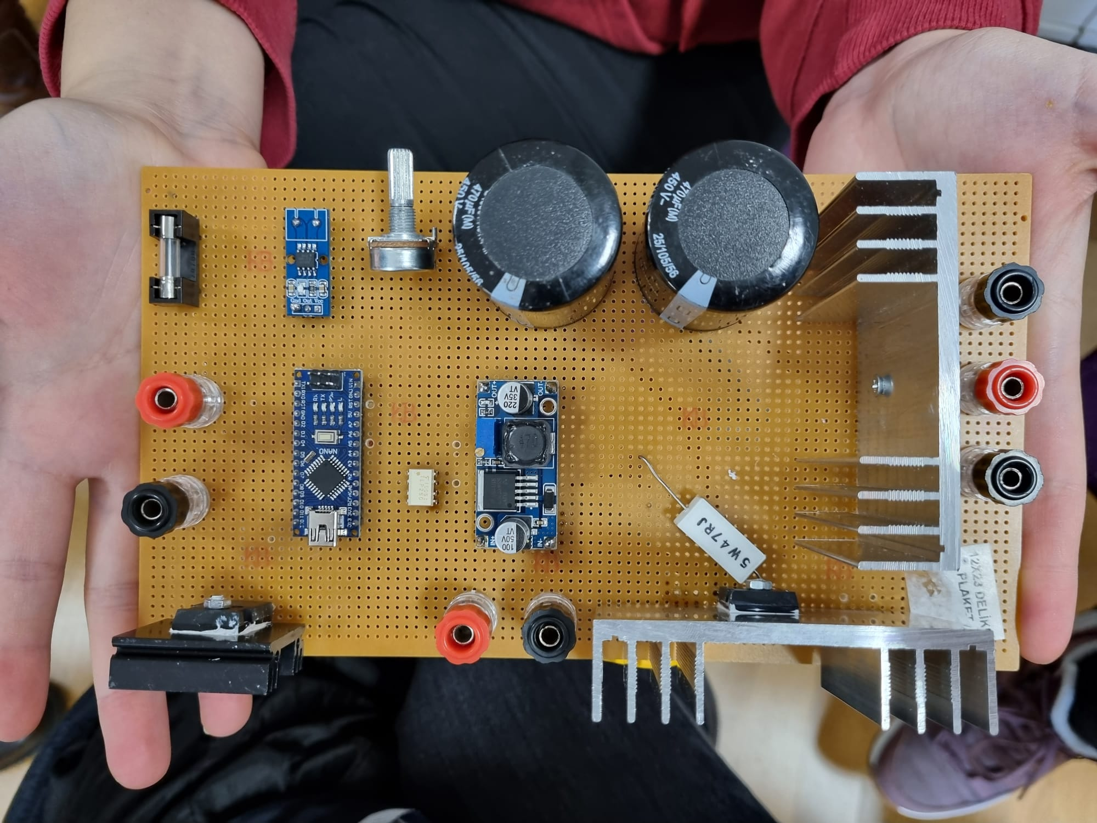

*Figure 37: Top view of the DC Motor Driver*

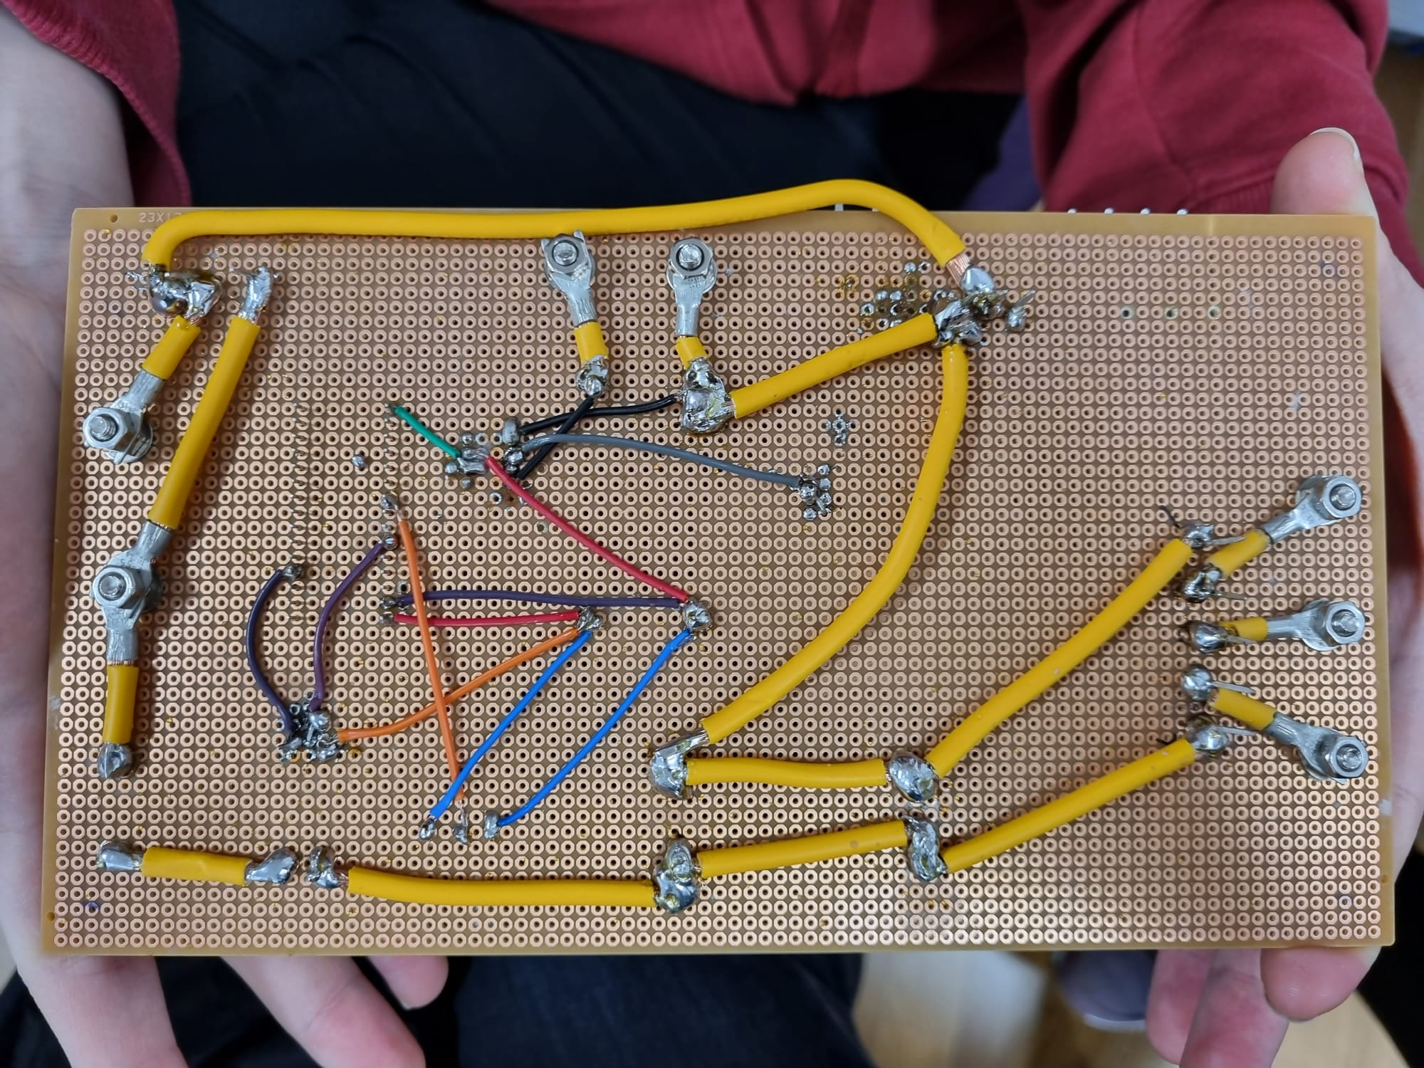

*Figure 38: Back View of the DC Motor Driver*

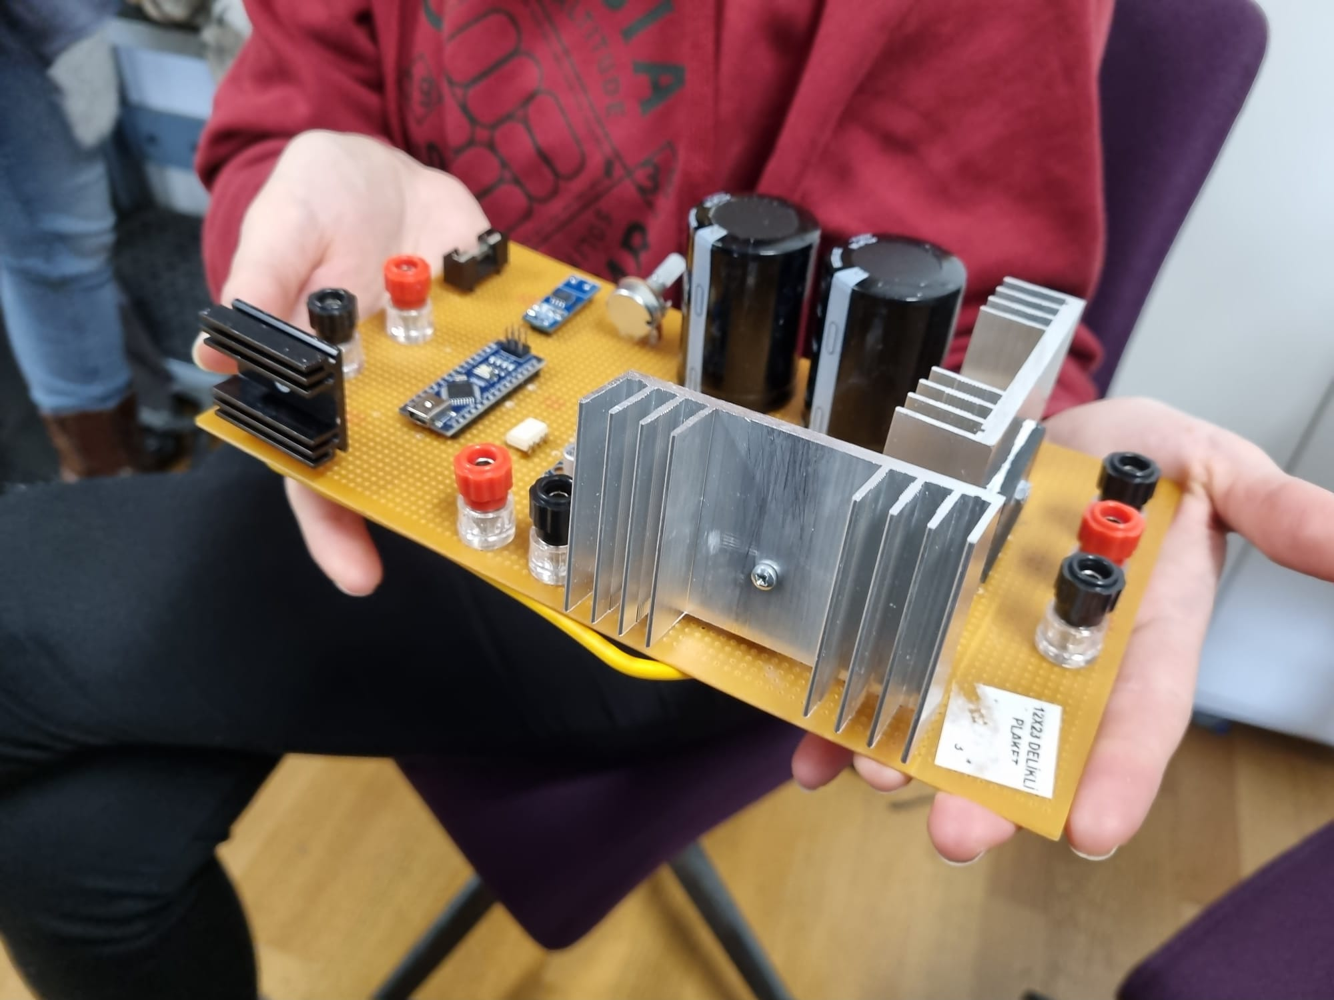

*Figure 39: Side view of the DC Motor Driver*

The size of the design:

Width: 12cm

Length: 23cm

Height: 5cm

In the design process, it was aimed that the wide bandgap semiconductor is used. This is because a wide-bandgap semiconductor has too small switching losses, and so higher efficiency is obtained. As a result, the LSIC2SD065A16A, which is a SiC diode, was determined to use. However, due to the supply problem, it could not be used.

When the feedback system was implemented, since the signal coming from the current sensor had some error, the control mechanism could not be implemented in the system. Therefore, rather than using POT as a duty cycle limiter, POT is used to control the duty cycle manually.

# Thermal Results

Thermal measurements were made when the load was connected.

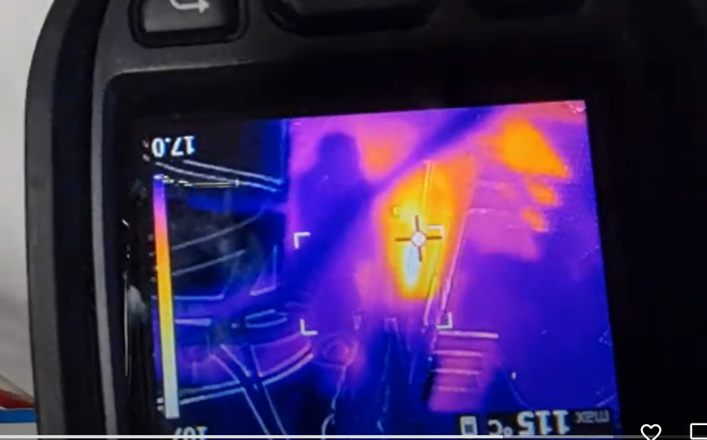

*Figure 40: Thermal Measurement of the Bridge Rectifier*

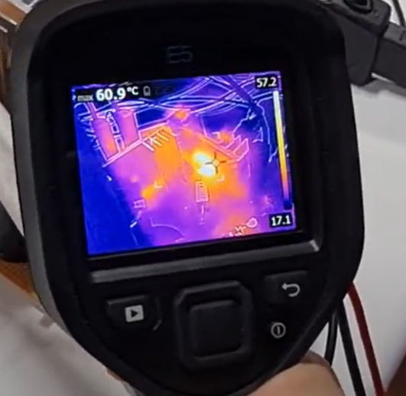

*Figure 41: Thermal Measurement of the IGBT*

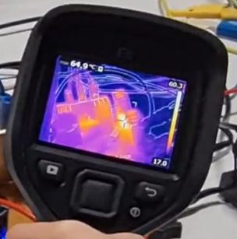

*Figure 42: Thermal Measurement of the Diode*

# Demo Day Results

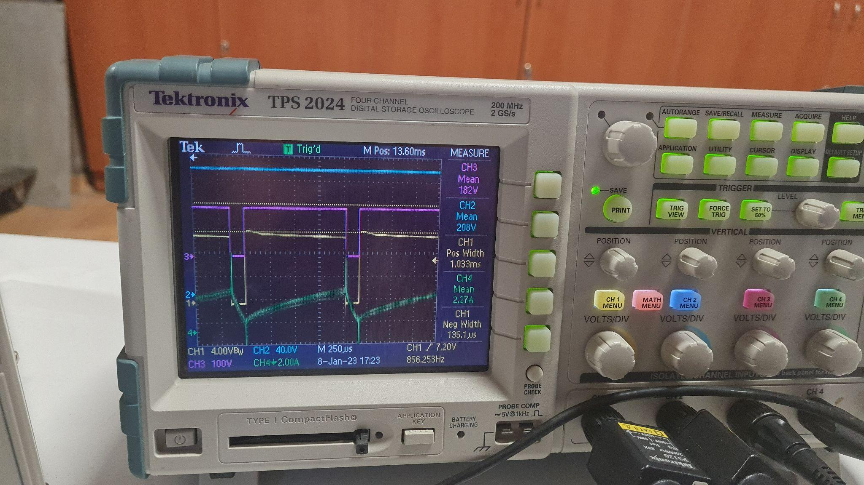

*Figure 43: Duty Cycle (CH1), Rectifier Output (CH2), Buck Converter Output Voltage (CH3), Output Current (CH4) Measurmrent at No Load Condition*

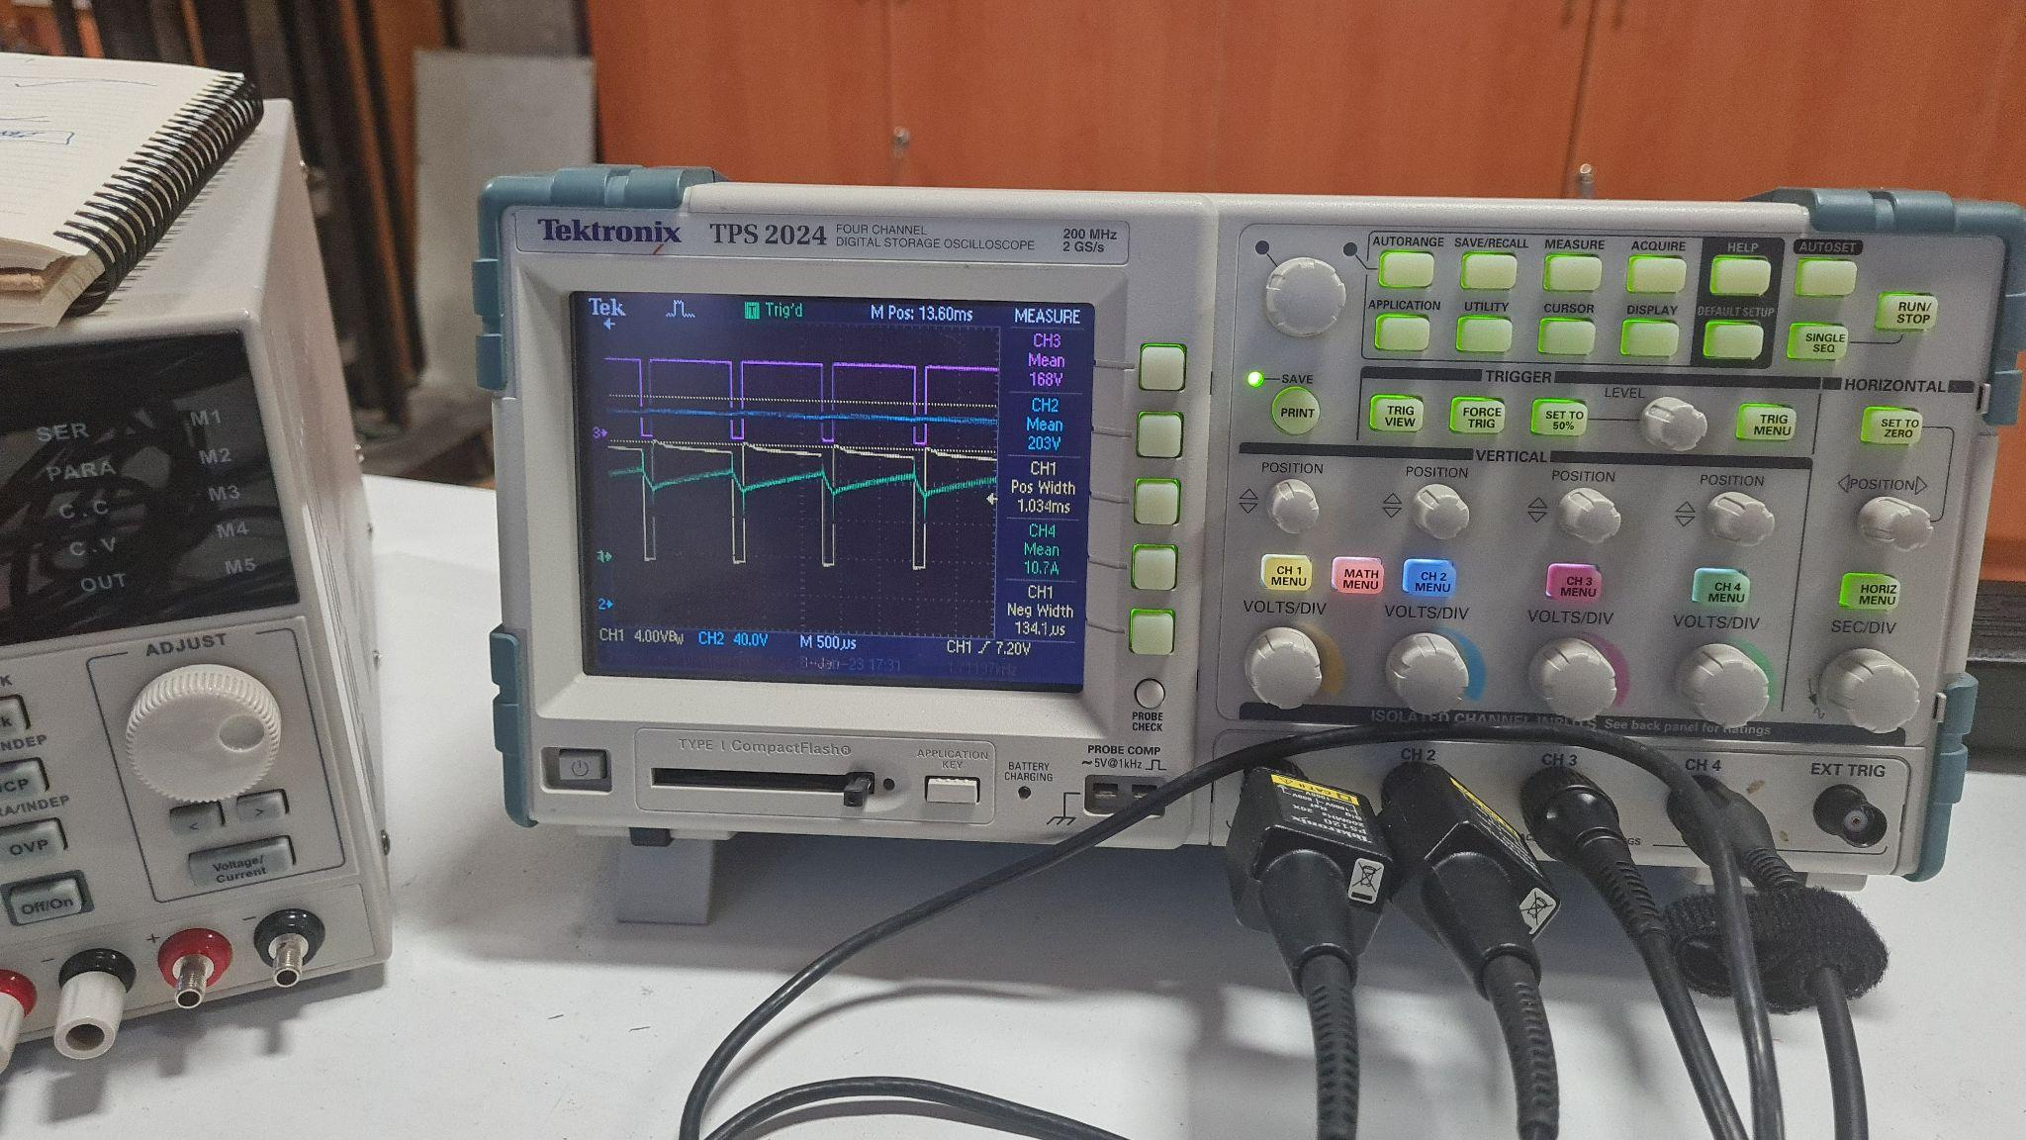

*Figure 44: Duty Cycle (CH1), Rectifier Output (CH2), Buck Converter Output Voltage (CH3), Output Current (CH4) Measurement at Load Condition*

In Figure 48, the output power of the driver was the 1.35kW

## 13.1. Comparison of Demo Day Results and Simulation Results

Table 6: Simulation and Demo Day Results at No Load Condition

|  | Simulation Result | Demo Day Result |
| --- | --- | --- |
| Rectifier Output Voltage | 232.2 V | 208 V |
| Buck Converter Output Voltage | 158.9 V | 182 V |
| Output Current | 1.9 A | 2.27 A |

Table 7: Simulation and Demo Day Results at Load Condition

|  | Simulation Result | Demo Day Result |
| --- | --- | --- |
| Rectifier Output Voltage | 228.1 V | 203 V |
| Buck Converter Output Voltage | 163.3 V | 188 V |
| Output Current | 10.2 A | 10.7 A |

On demo day, we applied the maximum duty cycle with POT. As a result, we gave different voltages from the variac to provide 180V to the motor.

When the graphs were examined, it could be seen that simulation and demo day results showed similar behavior. However, when the results are compared, as can be seen in Tables 6 and 7, the results are not similar.

Possible Reasons:

* The input voltage that came from variac is lower than the voltage in simulations.
* Field voltage can be higher in the experiment, which explains the increase in the Buck Converter Output Voltage at 1500 rpm.
* In the simulation, all components (except DC Motor) were assumed to be ideal.
* While simulating the design, we assumed that losses are constant and equal to 230 W, but as can be seen in Tables 6 and 7, when there is no load loss = 410W and at 1400W load loss = 518W. This explains the difference between the currents.

# Efficiency Calculation

$P_{in,AC}=1.4kW$

$P_{out}=1.35kW$

$Efficiency= 96.59\%$

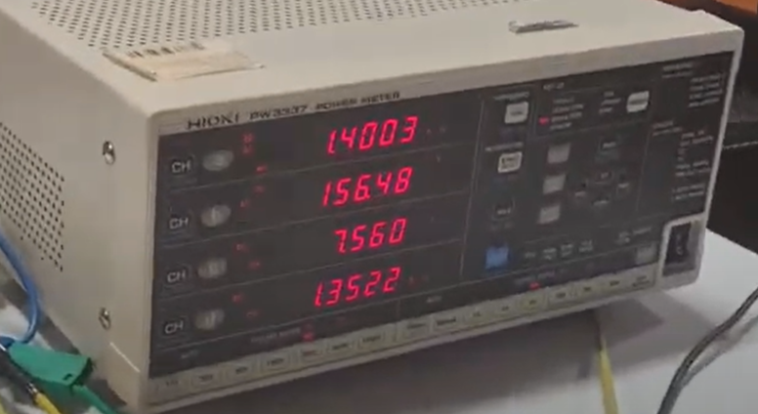

*Figure 45: The Power Meter Result at Load Condition*

# Conclusion

The aim of this project was to drive a DC motor with an AC input. The team first analyzed possible topologies and decided to use a three-phase diode rectifier with a buck converter for this project. According to that decision, the calculations of the rectifier and the converter were done. Following that, the team completed the power and loss calculations and started the simulations. During the simulation process continued throughout the project and evolved during that time. In order to make the changes and modifications clearly, both the first and final versions of the simulation layouts and plots can be found in this report. In the first simulations, a control system was tried to be simulated but then, with realizing that using a potentiometer is better, that part changed. And this control part and the reason why it is decided not to be used is explained in this report before explaining the driving unit needed for IGBT. The thermal calculations were done, and when the expectations and limitations were cleared, the team finalized the component selection and began the implementation. The implementation was decided to be done on a stripboard; the process and the respective images of the stripboard were added to the report. Finally, after finishing the implementation and dealing with the problems on the way, the design was tested in real-life conditions. The design was tested under different load conditions and successfully worked under almost all of them. The plots and thermal data were taken under the tests and compared to the simulation results in the report. The part when the design was unsuccessful was when it had to work under 2kW for several minutes. This was called the kettle test, and the aim was to keep working until the kettle boiled the water. The VA Method team design succeeds to work until the water is 70℃. At that point, the design stopped working, and after an examination, it was found that the optocoupler stopped working. The team was sure about the endurance power of the other components, and they were tested carefully, but the optocoupler was a component that no problem was expected. The team's judgment was that the optocoupler was damaged during the soiling process. With more time and experience, the team is confident that the design will work under all load conditions without any problem.

# Appendix

Bridge Rectifier - GUO40-12NO1 :

<https://ozdisan.com/guc-yari-iletkenleri/diyot-modul-diyot-dogrultucular/kopru-diyotlar/GUO40-12NO1>

IGBT - IXGH24N60C4D1

<https://www.ozdisan.com/guc-yari-iletkenleri/igbtler/discrete-igbtler/IXGH24N60C4D1>

Diode - DSEI30-06A

<https://www.ozdisan.com/guc-yari-iletkenleri/diyot-modul-diyot-dogrultucular/hizli-diyotlar/DSEI30-06A>

SiC Diode - LSIC2SD065A16A

<https://www.ozdisan.com/guc-yari-iletkenleri/diyotlar-modul-diyotlar-ve-dogrultucular/schottky-diyotlar/LSIC2SD065A16A>